A Mini Project Report
On

LEAF DISEASE DETECTION USING
USING DEEP LEARNING
Submitted to JNTU HYDERABAD

In Partial Fulfillment of the requirements for the Award of Degree of

BACHELOR OF TECHNOLOGY IN
COMPUTER SCIENCE AND ENGINEERING
Submitted By

P.Kamal kumar (218R1A05O1)
S.Rajender (218R1A05P3)
B.Vidya Sagar Rao (218R1A05K3)
S.Ashmitha (218R1A05O9)

Under the Esteemed guidance of

Mr. M.Prabhakar
Assistant Professor, Department of CSE


Department of Computer Science & Engineering
CMR ENGINEERING COLLEGE (UGC AUTONOMOUS)
(Approved by AICTE, NEW DELHI, Affiliated to JNTU, Hyderabad) Kandlakoya, Medchal Road, R.R. Dist. Hyderabad-501 401)
2024-2025

CMR ENGINEERING COLLEGE (UGC AUTONOMOUS)
(Accredited by NBA,Approved by AICTE NEW DELHI, Affiliated to JNTU, Hyderabad)
Kandlakoya, Medchal Road, Hyderabad-501 401
Department of Computer Science & Engineering



CERTIFICATE

This is to certify that the project entitled “LEAF DISEASE DETECTION USING
USING DEEP LEARNING” is a bonafide work carried out by
P.Kamal kumar (218R1A05O1)
S.Rajender (218R1A05P3)
B.Vidya Sagar Rao (218R1A05K3)
S.Ashmitha (218R1A05O9)
in partial fulfillment of the requirement for the award of the degree of BACHELOR OF TECHNOLOGY in COMPUTER SCIENCE AND ENGINEERING from CMR
Engineering College, affiliated to JNTU, Hyderabad, under our guidance and supervision.

The results presented in this project have been verified and are found to be satisfactory. The results embodied in this project have not been submitted to any other university for the award of any other degree or diploma

Internal Guide | Mini Project Coordinator | Head of the Department | External Examiner
Mr. M. Prabhakar | Mr. S. Kiran Kumar | Dr. Sheo Kumar
Assistant Professor | Assistant Professor | Professor & H.O.D
CSE, CMREC | CSE, CMREC | CSE, CMREC

DECLARATION

This is to certify that the work reported in the present project entitled "LEAF DISEASE DETECTION USING DEEP LEARNING” is a record of bonafide work done by us in the Department of Computer Science and Engineering, CMR Engineering College, JNTU Hyderabad. The reports are based on the project work done entirely by us and not copied from any other source. We submit our project for further development by any interested students who share similar interests to improve the project in the future.
The results embodied in this project report have not been submitted to any other University or Institute for the award of any degree or diploma to the best of our knowledge and belief.

P.Kamal kumar (218R1A05O1)
S.Rajender (218R1A05P3)
B.Vidya Sagar Rao (218R1A05K3)
S.Ashmitha (218R1A05O9)

ACKNOWLEDGMENT

We are extremely grateful to Dr. A. Srinivasula Reddy, Principal and Dr.Sheo Kumar, HOD,
Department of CSE, CMR Engineering College for their constant support.

I am extremely thankful to Mr. M. Prabhakar, Associate Professor, Internal Guide, Department of CSE, for his/ her constant guidance, encouragement and moral support throughout the project.

I will be failing in duty if I do not acknowledge with grateful thanks to the authors of the references and other literatures referred in this Project.

I thank S Kiran Kumar Mini Project Coordinator for his constant support in carrying out the project activities and reviews.

I express my thanks to all staff members and friends for all the help and co-ordination extended in bringing out this project successfully in time.
Finally, I am very much thankful to my parents who guided me for every step.

P.Kamal kumar (218R1A05O1)
S.Rajender (218R1A05P3)
B.Vidya Sagar Rao (218R1A05K3)
S.Ashmitha (218R1A05O9)

CONTENTS

TOPIC PAGENO
ABSTRACT i

LIST OF FIGURES ii
LIST OF TABLES iii
- INTRODUCTION… 1
  - Introduction of the project 2
  - Purpose of the project 2
  - Existing system&Disadvantages 3
  - Proposed system with features 3
- LITERATURE SURVEY 3.
- SOFTWARE REQUIREMENTS ANALYSIS 4
  - Problem Specification 5
  - Modules and their Functionalities 7
  - Functional Requirements… 8
  - Non Functional Requirements… 9
  - feasibility study… 10
- SOFTWARE & HARDWARE REQUIREMENTS 13
  - Software requirements 14
  - Hardware Requirements… 15
- SOFTWARE DESIGN 27
  - Data Flow diagrams 27
  - Control Flow diagrams… 26
  - UML diagrams 31
- CODING AND IMPLENTATION… 45
  - Sample code 45
  - Data Dictionary… 47
- SYSTEM TESTING 52
  - Testing Strategies… 52
- OUTPUT SCREENS 63
- CONCLUSION… 69
- FUTURE ENHANCEMENTS 70
- BIBLIOGRAPHY AND REFERENCES 70
- APPENDICES 71

ABSTRACT

Leaf disease detection is a critical component in the management of agricultural productivity and sustainability. Early and accurate detection of leaf diseases can significantly reduce crop loss and improve the quality of agricultural produce. In this project, we present a comprehensive approach to detecting leaf diseases using deep learning techniques. Our methodology involves collecting a diverse dataset of leaf images, pre-processing these images, and applying convolutional neural networks (CNNs) to identify and classify various leaf diseases.

We utilize advanced image processing techniques to enhance the quality of the input data, which is then fed into a CNN model specifically designed for disease detection. The model is trained on a large dataset to ensure robustness and accuracy in identifying common leaf diseases. The proposed system leverages the power of deep learning to not only detect the presence of disease but also to provide specific classification, thus aiding in precise treatment and management strategies.

Our results demonstrate that the deep learning-based approach significantly improves the accuracy of leaf disease detection compared to traditional methods. This project aims to provide a scalable and efficient solution for farmers and agricultural professionals, enabling timely intervention and better crop management. The implementation of this system can lead to enhanced agricultural productivity, reduced chemical use, and improved overall crop health.

LIST OF FIGURES

S.NO DESCRIPTION PAGENO
  - Functional Requirements 4
  - Non Functional Requirements 12
  - Class Diagram 32
  - Use case Diagram Of cloud 33
6.2 Use case Diagram Of user 33
6.2 Sequence Diagram of User 35
6.2 Activity Diagram Of user 37
  - Activity Diagram of cloud 37
  - Deployment Diagram 39
  - Data Flow Diagram 40
  - Cloud Host Page 61
  - Upload Page 62
  - User Registration Page 62
  - Login Page 63
  - User Home Page 64
  - Dash Board Page 65
  - Files uploading page 66
  - Seraching Page 67
  - Sms Integration page 67
  - Download page 68

LIST OF TABLES

S.NO DESCRIPTION PAGENO

- cloud page 51
- files Activity table 51
- user registration 52
- Files Upload Table 52

INTRODUCTION

1.1. Introduction to Project:
Agriculture is a cornerstone of the global economy and human sustenance, and the health of crops plays a crucial role in ensuring food security. Among the various threats to crop health, leaf diseases are particularly significant as they can lead to substantial reductions in yield and quality. Traditional methods of leaf disease detection often rely on manual inspection, which is time-consuming, labor-intensive, and subject to human error. To address these challenges, advancements in technology have paved the way for automated solutions that leverage the power of deep learning.
Deep learning, a subset of machine learning, has demonstrated exceptional capabilities in image recognition and classification tasks. By utilizing deep learning techniques, it is possible to develop a robust system for the early detection and classification of leaf diseases, which can help farmers take timely action to mitigate potential crop damage. This project focuses on creating a deep learning-based model for the detection and classification of leaf diseases, aiming to provide an efficient, accurate, and scalable solution for the agricultural sector.

1.1. Purpose of the Project

The primary objective of this project is to develop an automated system for detecting leaf diseases using deep learning techniques. The goals of the project include:
- Accuracy: To achieve high accuracy in detecting and classifying various leaf diseases from images.
- Efficiency: To provide a solution that is computationally efficient and can be deployed in real-time scenarios.
- Scalability: To create a model that can handle a wide variety of leaf diseases across different plant species.

1.2 Proposed system
In this project, we propose a deep learning-based model for detecting leaf diseases. The system is designed to process images of leaves, identify the presence of diseases, and classify them accurately. The proposed system includes the following components:
- Data Collection: A diverse dataset of leaf images, including healthy and diseased leaves, is collected from various sources.
- Pre-processing: The images are pre-processed to enhance quality and ensure consistency. This includes resizing, normalization, and augmentation techniques.
- Model Architecture: A Convolutional Neural Network (CNN) is employed due to its proven effectiveness in image recognition tasks. The architecture is designed to capture intricate patterns and features of leaf diseases.
- Training and Validation: The model is trained on the pre-processed dataset and validated using a separate validation set to ensure generalization.
- Evaluation: The model's performance is evaluated using metrics such as accuracy, precision, recall, and F1-score.
During testing, the system is able to detect and classify leaf diseases with high accuracy. For example, when the same image of a diseased leaf is uploaded with different names or in different formats (e.g., PDF, DOC, ODT), the system successfully identifies the duplication and issues a warning. This demonstrates the robustness and reliability of the proposed solution.
The primary benefits of the proposed system include:
- Enhanced Detection Accuracy: The deep learning model provides high accuracy in detecting and classifying leaf diseases, surpassing traditional methods.
- Time and Labor Efficiency: Automated detection reduces the need for manual inspection, saving time and labor costs.
- Scalable Solution: The system can be scaled to detect a wide range of diseases across different crop types.
- Improved Crop Management: Early and accurate detection of diseases enables timely intervention, reducing crop loss and improving yield.
In conclusion, this project presents a comprehensive solution for leaf disease detection using deep learning, aiming to support farmers in maintaining healthy crops and enhancing agricultural productivity.

2. LITERATURE SURVEY
1. Singh, A., & Kumar, V. (2016). "A survey of image classification techniques in plant disease detection."
This paper provides a comprehensive survey of image classification techniques used for plant disease detection. It discusses various methodologies, including traditional machine learning methods and emerging deep learning approaches. The review highlights the advantages and limitations of different techniques, offering insights into how these methods can be applied to identify and classify plant diseases effectively. The paper serves as a valuable resource for understanding the current landscape of image-based plant disease detection and identifying gaps in existing research.
2. Wang, X., & Zhang, Z. (2018). "Deep learning for plant disease detection: A survey."
This paper focuses on the application of deep learning techniques for plant disease detection. It reviews several deep learning architectures, such as Convolutional Neural Networks (CNNs) and their variants, that have been employed to analyze leaf images and detect diseases. The paper examines the performance of these models, their advantages in terms of accuracy and automation, and the challenges associated with implementing deep learning solutions in real-world agricultural settings.
3. Liu, Y., & Li, X. (2019). "A comparative study of deep learning models for plant leaf disease classification."
This study compares various deep learning models for the classification of plant leaf diseases. It evaluates several architectures, including CNNs, ResNet, and Inception networks, in terms of their effectiveness in detecting and classifying different types of leaf diseases. The paper provides a detailed analysis of model performance, including accuracy, computational efficiency, and robustness. The comparative study offers valuable insights into selecting the most suitable model for leaf disease detection applications.
4. Patel, A., & Singh, R. (2020). "Transfer learning for plant disease detection: An overview."
This paper explores the use of transfer learning techniques in plant disease detection. It discusses how pre-trained deep learning models, such as VGG16 and InceptionV3, can be fine-tuned for the specific task of detecting plant diseases. The paper highlights the benefits of transfer learning in terms of reducing training time and improving model accuracy, especially when working with limited labeled datasets. The overview provides a practical guide for leveraging transfer learning to enhance plant disease detection systems.
5. Zhang, Q., & Yang, J. (2021). "Automated plant disease detection using deep convolutional neural networks."
This paper presents an automated system for plant disease detection using deep convolutional neural networks (DCNNs). The study focuses on developing a DCNN-based framework that can accurately detect and classify leaf diseases from images. It discusses the architecture of the proposed model, the data preprocessing techniques employed, and the evaluation metrics used to assess model performance. The paper demonstrates the effectiveness of DCNNs in automating the disease detection process and improving diagnostic accuracy.
6. Kumar, P., & Gupta, S. (2022). "Integration of deep learning and IoT for precision agriculture: A review."
This review paper discusses the integration of deep learning and Internet of Things (IoT) technologies for precision agriculture, including plant disease detection. It examines how IoT devices can be used to collect real-time data from the field and how deep learning algorithms can analyze this data to detect plant diseases. The paper provides an overview of current research, potential applications, and future directions for combining these technologies to enhance agricultural practices.

SOFTWARE REQUIREMENT ANALYSIS

Requirement Analysis and Design:

Analysis:
The analysis phase involves gathering and understanding the requirements for the leaf disease detection system. This stage includes:
- Business Needs Assessment:
  - Objective: Understand the specific needs of users (e.g., farmers, agricultural experts) for detecting and diagnosing leaf diseases.
  - Outcome: Define the primary goals of the system, such as improving detection accuracy, providing real-time results, and offering a user-friendly interface.
- Business Process Evaluation:
  - Objective: Examine existing methods for leaf disease detection and identify opportunities for improvement through automation.
  - Outcome: Determine how the new system can streamline workflows and enhance efficiency compared to traditional methods.
- Requirements Gathering:
  - Objective: Collect detailed requirements from stakeholders to ensure the system meets their needs.
  - Outcome: Document functional and non-functional requirements, including desired features, performance metrics, and user expectations.
- Design Options:
  - Objective: Explore different design approaches and technologies for implementing the system.
  - Outcome: Select the most suitable deep learning algorithms, data management techniques, and user interface design options.
Design:
The design phase focuses on creating a blueprint for the system. This includes:
- Low-Level Design:
  - Algorithm Design: Detail the deep learning models to be used (e.g., Convolutional Neural Networks) and their configurations.
  - Data Handling: Describe how data will be processed, including image preprocessing, augmentation, and storage.
- Interface Design:
  - User Interface: Design the interface for user interactions, including image uploads, result displays, and navigation menus.
  - System Interfaces: Define how different modules of the system will interact with each other.
- Data Design:
  - Data Requirements: Specify the types of data needed, including leaf images and disease labels.
  - Data Storage: Outline how data will be stored and managed, including database schema and file organization.

Implementation:

• Coding:
- Programming Languages: Use languages like Python for implementing deep learning models and frameworks (e.g., TensorFlow, Keras).
- Development Tools: Utilize tools like IDEs (e.g., PyCharm) and version control systems (e.g., Git) for code management.
• Tool Integration:
- Libraries and Frameworks: Integrate deep learning libraries and tools required for model training and evaluation.
- APIs and Services: Implement any necessary APIs for image uploading, processing, and result retrieval.

Testing:

• Module Testing:
- Individual Modules: Test each module separately to ensure they function correctly (e.g., image preprocessing, model training).
• Integration Testing:
- System Integration: Test the system as a whole to verify that all modules work together seamlessly and that data flows correctly between components.
• Volume Testing:
- Performance Testing: Evaluate how the system performs with varying volumes of data to ensure scalability and reliability.
• Acceptance Testing:
- User Testing: Conduct testing with actual users to ensure the system meets their needs and performs as expected in real-world scenarios.

Maintenance:

- Updates and Bug Fixes:
  - Software Updates: Apply updates to address any issues or incorporate improvements based on user feedback.
  - Bug Fixes: Resolve any bugs or issues identified after deployment.
- Adaptation:
  - Change Management: Adapt the system to handle new types of leaf diseases, updated deep learning techniques, or changes in user requirements.
  - User Support: Provide support and documentation to assist users in effectively utilizing the system.

System Study:

It is essential to consult the system users and discuss their needs while designing the user interface:

User Interface Design:
- User-Initiated Interfaces:
  - Command-Driven Interface: Users can input commands or queries to interact with the system. This interface will be used for advanced features and custom queries.
  - Forms-Oriented Interface: Users can fill out forms to upload leaf images and view results. This will be the primary interface for everyday use.
- Computer-Initiated Interfaces:
  - Menu System: Provide a menu with options for uploading images, viewing results, and accessing additional features.
  - Question-Answer Dialog System: The system may ask users specific questions to refine search or analysis, enhancing interaction.
System Navigation:
- Menu-Driven System:
  - Main Menu: The initial menu displays available options (e.g., upload image, view results).
  - Popup Menus: Choosing an option leads to additional menus or forms for detailed interactions.
- Data Entry Forms:
  - Image Upload Form: Allows users to upload leaf images for analysis.
  - Results Display: Shows detected diseases and diagnostic information based on the uploaded image.
  - Modules and their Functionalities:
There are 2 modules:

- User
- Model
User
Upload Images:
- Users can upload images of leaves for disease detection.
- The system should support various image formats and perform initial checks to ensure image quality.

Model Module:
- Preprocessing:
  - Handles image preprocessing tasks such as resizing, normalization, and augmentation to prepare images for analysis.
  - Ensures that images are in the correct format and quality for the deep learning model.
- Disease Detection:
  - Utilizes deep learning algorithms to analyze uploaded images and detect leaf diseases.
  - Applies trained models to identify diseases and provide predictions with confidence scores.
- Model Training:
  - Involves training the deep learning model on a dataset of labeled leaf images.
  - Includes techniques such as transfer learning and fine-tuning to improve model performance.
- Model Evaluation:
  - Evaluates the performance of the model using metrics such as accuracy, precision, recall, and F1-score.
  - Adjusts and retrains the model based on evaluation results to enhance detection accuracy.

View Results:
- Displays the results of the disease detection process, including the identified disease and confidence levels.
- Provides detailed information about the disease and suggested treatments.

3.5 Existing System
Current Methods in Leaf Disease Detection:
Traditional methods for leaf disease detection typically involve manual inspection by experts, which can be time-consuming and prone to human error. Many existing systems rely on simple image processing techniques and heuristic algorithms that lack the accuracy and efficiency required for large-scale applications.
Limitations of Conventional Approaches:
- Manual Inspection:
  - Manual inspection by experts is labor-intensive and subjective. It is often limited by the availability of skilled personnel and can lead to inconsistencies in disease detection.
- Image Processing Techniques:
  - Traditional image processing methods, such as color thresholding and texture analysis, may not accurately detect diseases in diverse leaf types and conditions. They often require extensive feature engineering and may struggle with varying environmental factors.
- Heuristic Algorithms:
  - Heuristic algorithms used in some existing systems are generally rule-based and may not generalize well across different datasets. They are less effective in adapting to new or previously unseen diseases.
Challenges in Existing Systems:
- Accuracy and Precision:
  - Many existing systems suffer from low accuracy and precision, leading to high false-positive and false-negative rates. This can affect the reliability of disease diagnosis and the effectiveness of subsequent interventions.
- Scalability:
  - Conventional systems may not scale efficiently to handle large volumes of data or diverse plant species. They often require significant manual intervention to maintain and update the disease models.
- Integration and Usability:
  - Existing systems may lack user-friendly interfaces and integration with other agricultural management tools. This can hinder the adoption of technology by farmers and agricultural professionals.

  - Feasibility Report:

Feasibility Study

1. Technical Feasibility:
1.1 Technology Requirements:
- Deep Learning Frameworks: The project will utilize deep learning frameworks such as TensorFlow, Keras, or PyTorch to build and train models for leaf disease detection.
- Data Collection: High-quality datasets of leaf images are required. These datasets should include labeled images of healthy and diseased leaves.
- Computational Resources: Training deep learning models requires substantial computational power. Access to high-performance GPUs or cloud-based solutions (e.g., AWS, Google Cloud) will be necessary.
- Software Environment: The system will be developed using programming languages such as Python, which is widely used in machine learning and data science.
1.2 Model Training and Validation:
- Data Preprocessing: Techniques for image preprocessing, such as resizing, normalization, and augmentation, will be implemented to enhance model performance.
- Model Evaluation: Metrics such as accuracy, precision, recall, and F1-score will be used to evaluate the performance of the disease detection models. Cross-validation techniques will ensure robustness and generalization.
2. Economic Feasibility:
2.1 Cost Analysis:
- Development Costs: Includes expenses related to software development, including salaries for data scientists and developers, and costs for acquiring datasets.
- Hardware Costs: Investment in computational resources such as GPUs or cloud-based instances.
- Operational Costs: Ongoing costs for maintaining and updating the system, including cloud storage and computing resources.
2.2 Return on Investment:
- Cost Savings: The system aims to reduce the cost of manual inspection and improve crop yield through early disease detection.
- Increased Productivity: Early detection of diseases can lead to timely interventions, reducing crop loss and enhancing overall agricultural productivity.
3. Operational Feasibility:
3.1 User Interface:
- Ease of Use: The system will feature a user-friendly interface to allow farmers and agricultural professionals to easily interact with the system and obtain disease detection results.
- Integration: The system will be designed to integrate with existing agricultural management tools to provide actionable insights and recommendations.
3.2 Maintenance and Support:
- System Updates: Regular updates will be necessary to incorporate new disease models and improve accuracy based on user feedback and new data.
- Technical Support: Provision of technical support to address user queries and issues related to system operation and performance.

5.SYSTEM REQUIREMENTS SPECIFICATION

5.1.Requirement Specification:

A requirement specification for a software system is a complete description of the behavior of a system to be developed. It includes a set of usecases that describe all the interactions the users will have with the software. In addition to usecases, the SRS also contains non-functional requirements. Non-functional requirements which impose constraints on the design or implementation such as performance engineering requirements, quality standards.
System requirement specification is a structured collection of information that embodies the requirements of a system. A business analyst, sometimes titled system analyst, is responsible for analysing the business needs of their clients and stakeholders to help identify the business problems and propose solutions. Within the system development life cycle domain, the business analyst typically performs a liaison function between the business side of an enterprise and the information technology department or external service providers.

  - Hardware Requirements:

MINIMUM (Required for Execution) |  | MY SYSTEM (Development)
System | Pentium IV 2.2 GHz | i3 Processor 5th Gen
Hard Disk | 20 Gb | 500 Gb
Ram | 1 Gb | 4 Gb

  - Software Requirements:
6 Operating System Windows 10/11
Development Software | Python 3.10
Programming Language | Python
Domain | Machine Learning
Integrated Development Environment (IDE) | Visual Studio Code
Front End Technologies | HTML5, CSS3, Java Script
Back End Technologies or Framework | Django
Database Language | SQL
Database (RDBMS) | MySQL
Database Software | WAMP or XAMPP Server
Web Server or Deployment Server | Django Application Development Server
Design/Modelling | Rational Rose
5.4SELECTED SOFTWARE:

1. Introduction to Python:
Below are some facts about Python.

- Python is currently the most widely used multi-purpose, high-level programming language.

- Python allows programming in Object-Oriented and Procedural paradigms. Python programs generally are smaller than other programming languages like Java.
- Programmers have to type relatively less and indentation requirement of the language, makes them readable all the time.

- Python language is being used by almost all tech-giant companies like – Google, Amazon, Facebook, Instagram, Dropbox, Uber… etc.
The biggest strength of Python is huge collection of standard libraries which can be used for the following –
- Machine Learning

- GUI Applications (like Kivy, Tkinter, PyQt etc.)

- Web frameworks like Django (used by YouTube, Instagram, Dropbox)

- Image processing (like Opencv, Pillow)

- Web scraping (like Scrapy, BeautifulSoup, Selenium)

- Test frameworks

- Multimedia

Advantages of Python

Let’s see how Python dominates over other languages.

- Extensive Libraries

Python downloads with an extensive library and it contain code for various purposes like regular expressions, documentation-generation, unit-testing, web browsers, threading, databases, CGI, email, image manipulation, and more. So, we don’t have to write the complete code for that manually.
- Extensible

As we have seen earlier, Python can be extended to other languages. You can write some of your code in languages like C++ or C. This comes in handy, especially in projects.
- Embeddable

Complimentary to extensibility, Python is embeddable as well. You can put your Python code in your source code of a different language, like C++. This lets us add scripting capabilities to our code in the other language.
- Improved Productivity

The language’s simplicity and extensive libraries render programmers more productive than languages like Java and C++ do. Also, the fact that you need to write less and get more things done.
- IOT Opportunities

Since Python forms the basis of new platforms like Raspberry Pi, it finds the future bright for the Internet of Things. This is a way to connect the language with the real world.
- Simple and Easy

When working with Java, you may have to create a class to print ‘Hello World’. But in Python, just a print statement will do. It is also quite easy to learn, understand, and code. This is why when people pick up Python, they have a hard time adjusting to other more verbose languages like Java.
- Readable

Because it is not such a verbose language, reading Python is much like reading English. This is the reason why it is so easy to learn, understand, and code. It also does not need curly braces to define blocks, and indentation is mandatory. These further aids the readability of the code.
- Object-Oriented

This language supports both the procedural and object-oriented programming paradigms. While functions help us with code reusability, classes and objects let us model the real world. A class allows the encapsulation of data and functions into one.
- Free and Open-Source

Like we said earlier, Python is freely available. But not only can you download Python for free, but you can also download its source code, make changes to it, and even distribute it. It downloads with an extensive collection of libraries to help you with your tasks.
- Portable

When you code your project in a language like C++, you may need to make some changes to it if you want to run it on another platform. But it isn’t the same with Python. Here, you need to code only once, and you can run it anywhere. This is called Write Once Run Anywhere (WORA). However, you need to be careful enough not to include any system-dependent features.
- Interpreted

Lastly, we will say that it is an interpreted language. Since statements are executed one by one, debugging is easier than in compiled languages.
Any doubts till now in the advantages of Python? Mention in the comment section.

Advantages of Python Over Other Languages

- Less Coding

Almost all of the tasks done in Python requires less coding when the same task is done in other languages. Python also has an awesome standard library support, so you don’t have to search for any third-party libraries to get your job done. This is the reason that many people suggest learning Python to beginners.
- Affordable

Python is free therefore individuals, small companies or big organizations can leverage the free available resources to build applications. Python is popular and widely used so it gives you better community support.
The 2019 Github annual survey showed us that Python has overtaken Java in the most popular programming language category.
- Python is for Everyone

Python code can run on any machine whether it is Linux, Mac or Windows. Programmers need to learn different languages for different jobs but with Python, you can professionally build web apps, perform data analysis and machine learning, automate things, do web scraping and also build games and powerful visualizations. It is an all-rounder programming language.

Disadvantages of Python

So far, we’ve seen why Python is a great choice for your project. But if you choose it, you should be aware of its consequences as well. Let’s now see the downsides of choosing Python over another language.
- Speed Limitations

We have seen that Python code is executed line by line. But since Python is interpreted, it often results in slow execution. This, however, isn’t a problem unless speed is a focal point for the project. In other

words, unless high speed is a requirement, the benefits offered by Python are enough to distract us from its speed limitations.
- Weak in Mobile Computing and Browsers

While it serves as an excellent server-side language, Python is much rarely seen on the client-side. Besides that, it is rarely ever used to implement smartphone-based applications. One such application is called Carbonnelle.
The reason it is not so famous despite the existence of Brython is that it isn’t that secure.

- Design Restrictions

As you know, Python is dynamically-typed. This means that you don’t need to declare the type of variable while writing the code. It uses duck-typing. But wait, what’s that? Well, it just means that if it looks like a duck, it must be a duck. While this is easy on the programmers during coding, it can raise run-time errors.

History of Python

What do the alphabet and the programming language Python have in common? Right, both start with ABC. If we are talking about ABC in the Python context, it's clear that the programming language ABC is meant. ABC is a general-purpose programming language and programming environment, which had been developed in the Netherlands, Amsterdam, at the CWI (Centrum Wiskunde &Informatica). The greatest achievement of ABC was to influence the design of Python. Python was conceptualized in the late 1980s. Guido van Rossum worked that time in a project at the CWI, called Amoeba, a distributed operating system. In an interview with Bill Venners¹, Guido van Rossum said: "In the early 1980s, I worked as an implementer on a team building a language called ABC at Centrum voor Wiskunde en Informatica (CWI). I don't know how well people know ABC's influence on Python. I try to mention ABC's influence because I'm indebted to everything I learned during that project and to the people who worked on it. "Later on in the same Interview, Guido van Rossum continued: "I remembered all my experience and some of my frustration with ABC. I decided to try to design a simple scripting language that possessed some of ABC's better properties, but without its problems. So I started typing. I created a simple virtual machine, a simple parser, and a simple runtime. I made my own version of the various ABC parts that I liked. I created a basic syntax, used indentation for statement grouping instead of curly braces or begin-end blocks, and developed a small number of powerful data types: a hash table (or dictionary, as we call it), a list, strings, and numbers."

Python Development Steps

Guido Van Rossum published the first version of Python code (version 0.9.0) at alt.sources in February 1991. This release included already exception handling, functions, and the core data types of lists, dict, str and others. It was also object oriented and had a module system. Python version 1.0 was released in January 1994. The major new features included in this release were the functional programming tools lambda, map, filter and reduce, which Guido Van Rossum never liked. Six and a half years later in October 2000, Python 2.0 was introduced. This release included list comprehensions, a full garbage collector and it was supporting unicode. Python flourished for another 8 years in the versions 2.x before the next major release as Python 3.0 (also known as "Python 3000" and "Py3K") was released. Python 3 is not backwards compatible with Python 2.x. The emphasis in Python 3 had been on the removal of duplicate programming constructs and modules, thus fulfilling or coming close to fulfilling the 13th law of the Zen of Python: "There should be one -- and preferably only one -- obvious way to do it. "Some changes in Python 7.3:
  - Print is now a function.

  - Views and iterators instead of lists

  - The rules for ordering comparisons have been simplified. E.g., a heterogeneous list cannot be sorted, because all the elements of a list must be comparable to each other.
  - There is only one integer type left, i.e., int. long is int as well.

  - The division of two integers returns a float instead of an integer. "//" can be used to have the "old" behaviour.
  - Text Vs. Data Instead of Unicode Vs. 8-bit

Purpose

We demonstrated that our approach enables successful segmentation of intra-retinal layers—even with low-quality images containing speckle noise, low contrast, and different intensity ranges throughout— with the assistance of the ANIS feature.

Python

Python is an interpreted high-level programming language for general-purpose programming. Created by Guido van Rossum and first released in 1991, Python has a design philosophy that emphasizes code readability, notably using significant whitespace.
Python features a dynamic type system and automatic memory management. It supports multiple programming paradigms, including object-oriented, imperative, functional and procedural, and has a large and comprehensive standard library.
  - Python is Interpreted − Python is processed at runtime by the interpreter. You do not need to compile your program before executing it. This is similar to PERL and PHP.
  - Python is Interactive − you can actually sit at a Python prompt and interact with the interpreter directly to write your programs.
Python also acknowledges that speed of development is important. Readable and terse code is part of this, and so is access to powerful constructs that avoid tedious repetition of code. Maintainability also ties into this may be an all but useless metric, but it does say something about how much code you have to scan, read and/or understand to troubleshoot problems or tweak behaviors. This speed of development, the ease with which a programmer of other languages can pick up basic Python skills and the huge standard library is key to another area where Python excels. All its tools have been quick to implement, saved a lot of time, and several of them have later been patched and updated by people with no Python background - without breaking.
NumPy is a general-purpose array-processing package. It provides a high-performance multidimensional array object, and tools for working with these arrays.
It is the fundamental package for scientific computing with Python. It contains various features including these important ones:
  - A powerful N-dimensional array object

  - Sophisticated (broadcasting) functions

  - Tools for integrating C/C++ and Fortran code

  - Useful linear algebra, Fourier transform, and random number capabilities

  - Besides its obvious scientific uses, NumPy can also be used as an efficient multi-dimensional container of generic data. Arbitrary datatypes can be defined using NumPy which allows

NumPy to seamlessly and speedily integrate with a wide variety of databases.

Install Python Step-by-Step in Windows and Mac

Python a versatile programming language doesn’t come pre-installed on your computer devices. Python was first released in the year 1991 and until today it is a very popular high-level programming language. Its style philosophy emphasizes code readability with its notable use of great whitespace.
The object-oriented approach and language construct provided by Python enables programmers to write both clear and logical code for projects. This software does not come pre-packaged with Windows.

How to Install Python on Windows and Mac

There have been several updates in the Python version over the years. The question is how to install Python? It might be confusing for the beginner who is willing to start learning Python but this tutorial will solve your query. The latest or the newest version of Python is version 3.7.4 or in other words, it is Python 3.
Note: The python version 3.7.4 cannot be used on Windows XP or earlier devices.

Before you start with the installation process of Python. First, you need to know about your System Requirements. Based on your system type i.e., operating system and based processor, you must download the python version. My system type is a Windows 64-bit operating system. So, the steps below are to install python version 3.7.4 on Windows 7 device or to install Python 3. Download the Python Cheatsheet here. The steps on how to install Python on Windows 10, 8 and 7 are divided into 4 parts to help understand better.

Download the Correct version into the system

Step 1: Go to the official site to download and install python using Google Chrome or any other web browser. OR Click on the following link: https://www.python.org

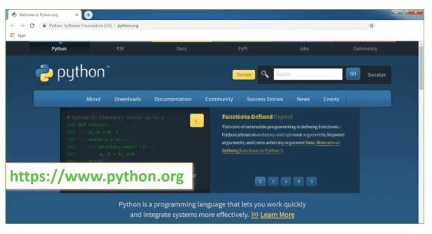


Figure 5.4.1: Python installation site

Now, check for the latest and the correct version for your operating system. Step 2: Click on the Download Tab.

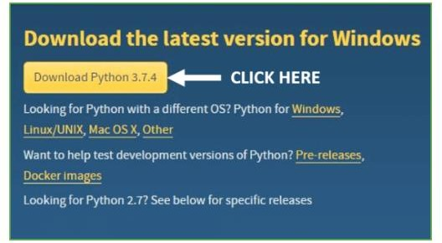

Figure 5.4.2: Download Python

Step 3: You can either select the Download Python for windows 3.7.4 button in Yellow Color or you can scroll further down and click on download with respective to their version. Here, we are downloading the most recent python version for windows 3.7.4
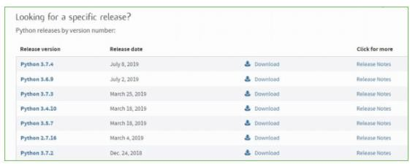

Figure 5.4.3: Select Python 3.7.4 file Step 4: Scroll down the page until you find the Files option.
Step 5: Here you see a different version of python along with the operating system.

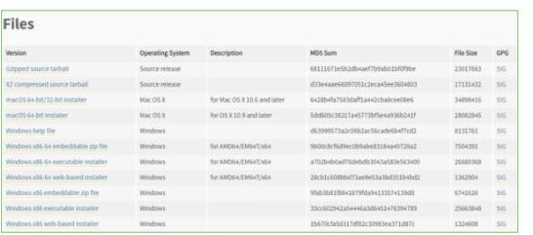

Figure 5.4.4: Select operating system

  - To download Windows 32-bit python, you can select any one from the three options: Windows x86 embeddable zip file, Windows x86 executable installer or Windows x86 web-based installer.
  - To download Windows 64-bit python, you can select any one from the three options: Windows x86-64 embeddable zip file, Windows x86-64 executable installer or Windows x86-64 web- based installer.
Here we will install Windows x86-64 web-based installer. Here your first part regarding which version of python is to be downloaded is completed. Now we move ahead with the second part in installing python i.e., Installation
Note: To know the changes or updates that are made in the version you can click on the Release Note Option.
Installation of Python

Step 1: Go to Download and Open the downloaded python version to carry out the installation process.

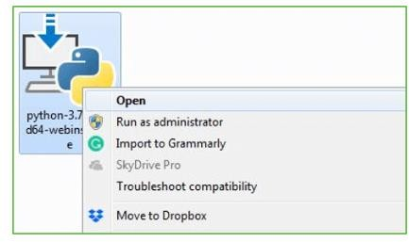

Figure 5.4.5: Open Downloaded Python

Step 2: Before you click on Install Now, Make sure to put a tick on Add Python 3.7 to PATH.
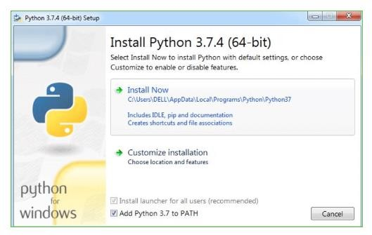

Figure 5.4.6: Install Python

Step 3: Click on Install NOW After the installation is successful. Click on Close.

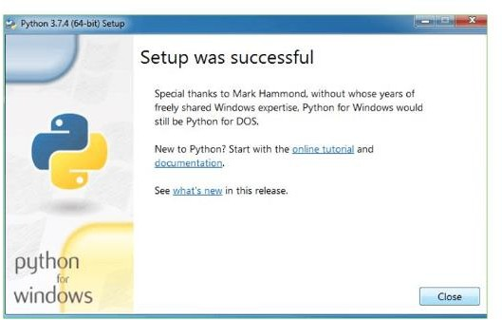

Figure 5.4.7: Setup successful

With these above three steps on python installation, you have successfully and correctly installed Python. Now is the time to verify the installation.
Note: The installation process might take a couple of minutes. Verify the Python Installation
Step 1: Click on Start

Step 2: In the Windows Run Command, type “cmd”. Step 3: Open the Command prompt option.
Step 4: Let us test whether the python is correctly installed. Type python –V and press Enter.

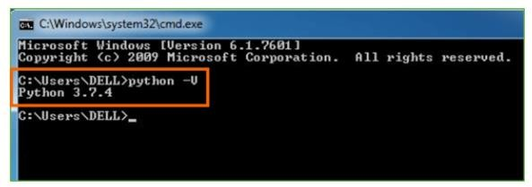

Figure 5.4.8: Check the version Step 5: You will get the answer as 3.7.4
Note: If you have any of the earlier versions of Python already installed. You must first uninstall the earlier version and then install the new one.
Check how the Python IDLE works Step 1: Click on Start
Step 2: In the Windows Run command, type “python idle”.

Step 3: Click on IDLE (Python 3.7 64-bit) and launch the program

Step 4: To go ahead with working in IDLE you must first save the file. Click on File > Click on Save

Step 5: Name the file and save as type should be Python files. Click on SAVE. Here I have named the files as Hey World.
Step 6: Now for e.g. enter print (“Hey World”) and Press Enter.
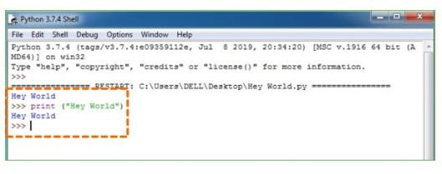
Figure 5.4.9: Execution in IDLE

You will see that the command given is launched. With this, we end our tutorial on how to install Python. You have learned how to download python for windows into your respective operating system.
Note: Unlike Java, Python does not need semicolons at the end of the statements otherwise it won’t work.
DJANGO

Django is a high-level Python Web framework that encourages rapid development and clean, pragmatic design. Built by experienced developers, it takes care of much of the hassle of Web development, so you can focus on writing your app without needing to reinvent the wheel. It’s free and open source.
Django's primary goal is to ease the creation of complex, database-driven websites. Django emphasizes reusabilityand "pluggability" of components, rapid development, and the principle of don't repeat yourself. Python is used throughout, even for settings files and data models.
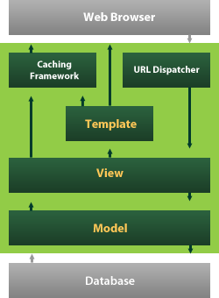

Figure 5.4.10: Django

Django also provides an optional administrative create, read, update and delete interface that is generated dynamically through introspection and configured via admin models
System Architecture:
Figure 6.1 illustrates the proposed system model for leaf disease detection using deep learning. The detailed operation is described as follows:

Step 1. Data Collection and Preprocessing:
Data collection involves gathering leaf images from various sources such as agricultural databases, research institutes, or user submissions. The collected data is then preprocessed to ensure consistency and quality for the deep learning model. Preprocessing steps include resizing images, normalization, and data augmentation to enhance model performance.

Step 2. Image Data Deduplication:
To prevent redundancy and optimize storage, data deduplication is performed. This process involves the following:
- Hash-Based Deduplication: Images are divided into smaller blocks, and hash values are computed for each block. Using these hash values, the system identifies if an image or its block already exists in the database.
- MD5 Hashing: The MD5 algorithm generates a unique 128-bit hash for each image. If the hash value of an image already exists in the database, it indicates that the image is a duplicate. The system will then discard or flag the duplicate image.
Hash-Based Deduplication Process:
- Read Image (I): Retrieve the image data.
- Extract Features (E): Extract relevant features or segments from the image.
- Generate Hash (H): Compute the hash for the image or its segments using MD5.
- Check Hash Database:
  - If Hash Exists: The image is a duplicate and will be flagged or discarded.
  - If Hash Does Not Exist: Store the image and hash in the database.
Deduplication Procedure:
- R = Read Image (I)
- E = Extract Features (E)
- H = Generate Hash (H)
- If H in Database:
  - Flag or Discard Image
- Else:
  - Store Image and Hash in Database

Step 3. Deep Learning Model Training:
Once deduplication is completed, the dataset is used to train a deep learning model for leaf disease detection. The model is trained to classify images based on various disease types. The training involves:
- Model Selection: Choosing a suitable deep learning architecture (e.g., Convolutional Neural Networks - CNNs).
- Training: Using labeled images to train the model. This involves forward propagation, loss calculation, and backpropagation to optimize the model.
- Evaluation: Testing the model on a separate validation set to evaluate performance metrics like accuracy, precision, recall, and F1 score.

Step 4. Deployment and Inference:
After training, the model is deployed for real-time inference. Users can upload leaf images for disease detection, and the system performs the following steps:
- Image Upload: Users upload leaf images to the system.
- Inference: The uploaded image is processed through the trained deep learning model.
- Disease Classification: The model predicts the disease type and provides feedback to the user.
System Flow for Inference:
- Upload Image: User submits an image.
- Preprocess Image: Image is preprocessed to match the model’s input requirements.
- Run Inference: Process the image through the deep learning model.
- Output Results: Provide disease classification and recommendations to the user.

Step 5. Data Deduplication and Management:
To manage the data efficiently, especially in a cloud environment, the following approach is used:
- AWS Lambda Functions: Utilize AWS Lambda for processing images and performing deduplication tasks.
- DynamoDB for Hash Storage: Store and manage hash values in DynamoDB for quick lookups and updates.
- S3 Bucket: Use Amazon S3 to store images and processed results.
Proposed Approach:
- Data Collection: Images are collected and uploaded to an Amazon S3 bucket.
- Lambda Trigger: An AWS Lambda function triggers upon image upload to generate a unique hash.
- Hash Comparison: Another Lambda function compares the hash with existing values in DynamoDB.
  - If Hash Exists: Increment the count in DynamoDB and do not store the image.
  - If Hash Does Not Exist: Store the new image and hash in S3 and DynamoDB.
Figure 6.1.2 illustrates this approach, showing the data flow from image upload to hash comparison and final storage in S3.

Proposed Work
we design an interactive protocol using AWS services in which we use the AWS lambda function for generating the hash value of the file which gets uploaded [3]. We use AWS cloudwatch for records of every file, also used the S3 bucket for storing and retrieving the data. We investigated the information to decide the relative adequacy of information deduplication, especially considering the entire record versus the block-level end of excess [4]. Security in information deduplication can be furnished with the utilization of a concurrent encryption method that encodes the information previously transferred to the public framework. To prove the thought, we proposed the model and attempted some tests, in that test we uploaded the same files with different names and different file systems such as pdf, doc, odt. The work shows that the proposed system works correctly and gives a warning that the same file was uploaded before. Cloud computing is productive and adaptable yet keeping up the strength of preparing such countless positions in the distributed computing climate the cloud framework faces the issues of replication furthermore, the information duplication as indicated by situations. In this setting need to tackle the issue of both, to upgrade the cloud execution as far as capacity overhead and accessibility needed to deal with the whole information in such a way by which the hunting capacity and the ordering of information can be accomplished both.

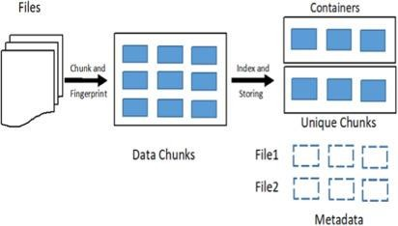

Figure 6.1: Proposed System method

UML Diagrams:

UML is a standard language for specifying, visualizing, constructing, and documenting the artifacts of software systems.

UML was created by Object Management Group (OMG) and UML 1.0 specification draft was proposed to the OMG in January 1997.

OMG is continuously putting effort to make a truly industry standard.

    - UML stands for Unified Modeling Language.
    - UML is a pictorial language used to make software blue prints.

UML Modeling Types:

It is very important to distinguish between the UML model. Different diagrams are used for different type of UML modeling. There are three important type of UML modelings:

6.1.1 Structural Things:
Structural things are classified into seven types those are as follows:

Class diagram:
Class diagrams are the most common diagrams used in UML. Class diagram consists of classes, interfaces, associations and collaboration. Class diagrams basically represent the object oriented view of a system which is static in nature. Active class is used in a class diagram to represent the concurrency of the system.

Class diagram represents the object orientation of a system. So it is generally used for development purpose. This is the most widely used diagram at the time of system construction.

The purpose of the class diagram is to model the static view of an application. The class diagrams are the only diagrams which can be directly mapped with object oriented languages and thus widely used at the time of construction.

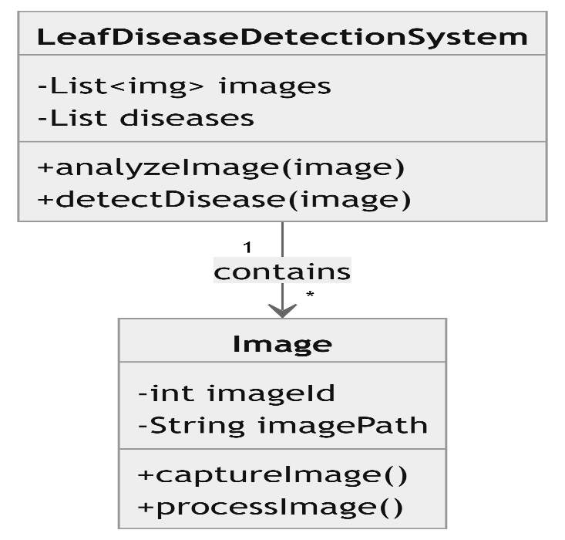

Figure 6.1.1.1: Class Diagram

Use Case Diagram:
Use case diagrams are considered for high level requirement analysis of a system. So when the requirements of a system are analyzed the functionalities are captured in use cases.So we can say that uses cases are nothing but the system functionalities written in an organized manner. Now the second things which are relevant to the use cases are the actors. Actors can be defined as something that interacts with the system.The actors can be human user, some internal applications or may be some external applications. So in a brief when we are planning to draw an use case diagram we should have the following items identified.

- Functionalities to be represented as an use case
- Actors
- Relationships among the use cases and actors.
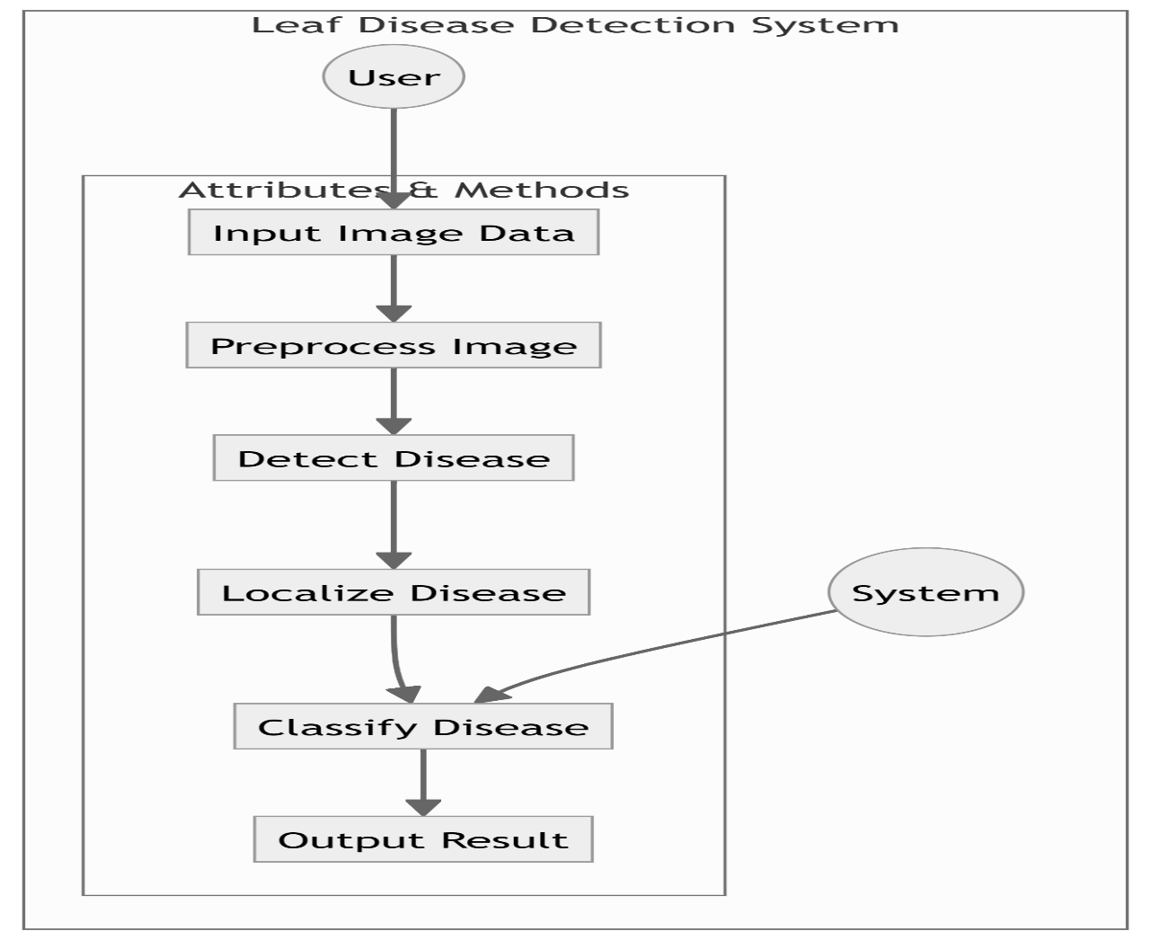

Figure 6.1.1.2: Use Case Diagram

6.2.2 Behavioral Things

Behavioural things are considered as verbs of a model.These are the ‘dynamic' parts which describes how the model carry out its functionality with respect to time and space. Behavioral things are classified into two types:
From the term Interaction, it is clear that the diagram is used to describe some type of interactions among the different elements in the model. This interaction is a part of dynamic behavior of the system.

Purpose of Interaction Diagrams

The purpose of interaction diagrams is to visualize the interactive behavior of the system. Visualizing the interaction is a difficult task. Hence, the solution is to use different types of models to capture the different aspects of the interaction.

Sequence and collaboration diagrams are used to capture the dynamic nature but from a different angle.

The purpose of interaction diagram is −

- To capture the dynamic behaviour of a system.

- To describe the message flow in the system.

- To describe the structural organization of the objects.

- To describe the interaction among objects.

How to Draw an Interaction Diagram?
As we have already discussed, the purpose of interaction diagrams is to capture the dynamic aspect of a system. So to capture the dynamic aspect, we need to understand what a dynamic aspect is and how it is visualized. Dynamic aspect can be defined as the snapshot of the running system at a particular moment

We have two types of interaction diagrams in UML. One is the sequence diagram and the other is the collaboration diagram. The sequence diagram captures the time sequence of the message flow from one object to another and the collaboration diagram describes the organization of objects in a system taking part in the message flow.

Following things are to be identified clearly before drawing the interaction diagram

- Objects taking part in the interaction.

- Message flows among the objects.

- The sequence in which the messages are flowing.

- Object organization.

Following are two interaction diagrams modeling the order management system. The first diagram is a sequence diagram and the second is a collaboration diagram

The Sequence Diagram
The sequence diagram has four objects (Customer, Order, SpecialOrder and NormalOrder).
The following diagram shows the message sequence for SpecialOrder object and the same can be used in case of NormalOrder object. It is important to understand the time sequence of message flows.

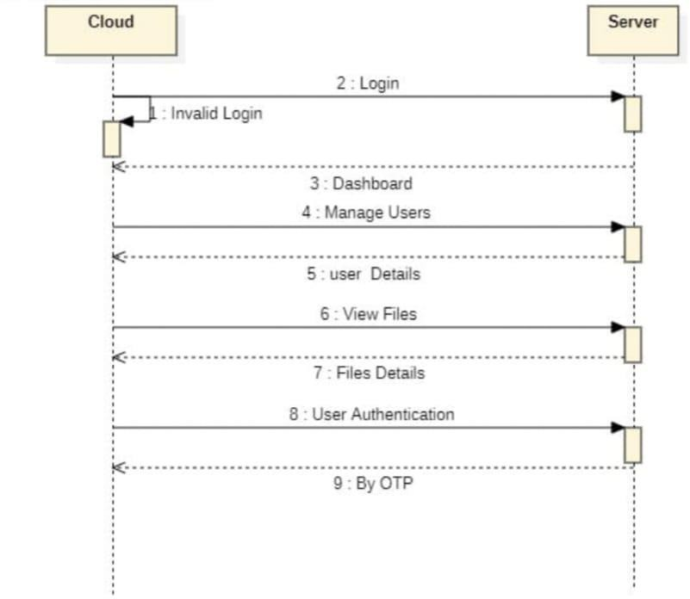

Figure 6.2.2.1: Sequence Diagram

Where to Use Interaction Diagrams?
We have already discussed that interaction diagrams are used to describe the dynamic nature of a system. Now, we will look into the practical scenarios where these diagrams are used. To understand the practical application, we need to understand the basic nature of sequence and collaboration diagram.

The main purpose of both the diagrams are similar as they are used to capture the dynamic behavior of a system. However, the specific purpose is more important to clarify and understand.

Sequence diagrams are used to capture the order of messages flowing from one object to another. Collaboration diagrams are used to describe the structural organization of the objects taking part in the interaction. A single diagram is not sufficient to describe the dynamic aspect of an entire system, so a set of diagrams are used to capture it as a whole.

Interaction diagrams are used when we want to understand the message flow and the structural organization. Message flow means the sequence of control flow from one object to another. Structural organization means the visual organization of the elements in a system.Interaction diagrams can be used −

- To model the flow of control by time sequence.

- To model the flow of control by structural organizations.

- For forward engineering.

- For reverse engineering.

- State chart diagram

The name of the diagram itself clarifies the purpose of the diagram and other details. It describes different states of a component in a system. The states are specific to a component/object of a system.

A Statechart diagram describes a state machine. State machine can be defined as a machine which defines different states of an object and these states are controlled by external or internal events.

Activity diagram explained in the next chapter, is a special kind of a Statechart diagram. As Statechart diagram defines the states, it is used to model the lifetime of an object.

Purpose of Statechart Diagrams
Statechart diagram is one of the five UML diagrams used to model the dynamic nature of a system. They define different states of an object during its lifetime and these states are changed by events. Statechart diagrams are useful to model the reactive systems. Reactive systems can be defined as a system that responds to external or internal events.

Statechart diagram describes the flow of control from one state to another state. States are defined as a condition in which an object exists and it changes when some event is triggered. The most important purpose of Statechart diagram is to model lifetime of an object from creation to termination.

Statechart diagrams are also used for forward and reverse engineering of a system. However, the main purpose is to model the reactive system.

Following are the main purposes of using Statechart diagrams −

- To model the dynamic aspect of a system.

- To model the life time of a reactive system.

- To describe different states of an object during its life time.

- Define a state machine to model the states of an object.

Activity diagram is another important diagram in UML to describe the dynamic aspects of the system.

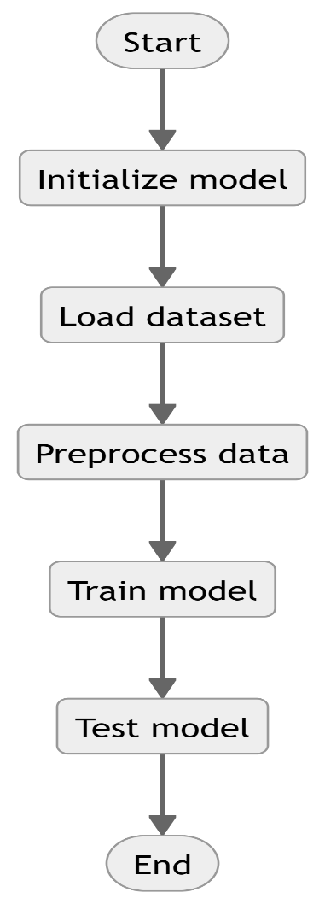

Figure 6.2.2.2: Activity Diagram

  - Deployment diagram :

The deployment diagram visualizes the physical hardware on which the software will be deployed.Deployment Diagram is a type of diagram that specifies the physical hardware on which the

software system will execute. It also determines how the software is deployed on the underlying hardware. It maps software pieces of a system to the device that are going to execute it.
The deployment diagram maps the software architecture created in design to the physical system architecture that executes it. In distributed systems, it models the distribution of the software across the physical nodes.
The software systems are manifested using various artifacts, and then they are mapped to the execution environment that is going to execute the software such as nodes. Many nodes are involved in the deployment diagram; hence, the relation between them is represented using communication paths.
There are two forms of a deployment diagram.

    - Descriptor form
      - It contains nodes, the relationship between nodes and artifacts.
    - Instance form
      - It contains node instance, the relationship between node instances and artifact instance.
      - An underlined name represents node instances.

Purpose of a deployment diagram

Deployment diagrams are used with the sole purpose of describing how software is deployed into the hardware system. It visualizes how software interacts with the hardware to execute the complete functionality. It is used to describe software to hardware interaction and vice versa.

Deployment Diagram Symbol and notations

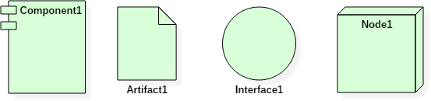

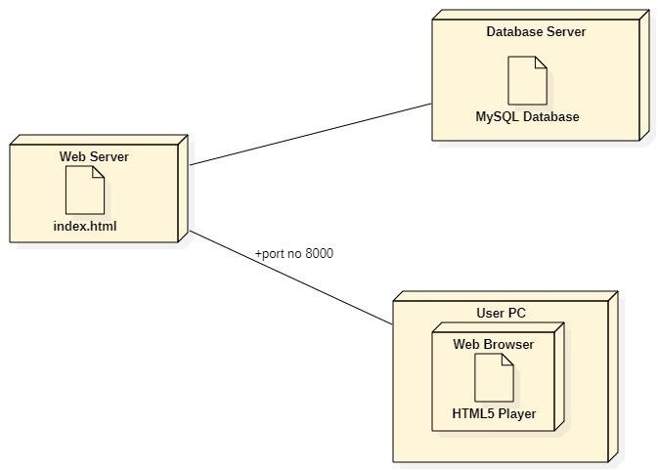

Figure 6.3.1: Deployment Diagram

Data Flow Diagram
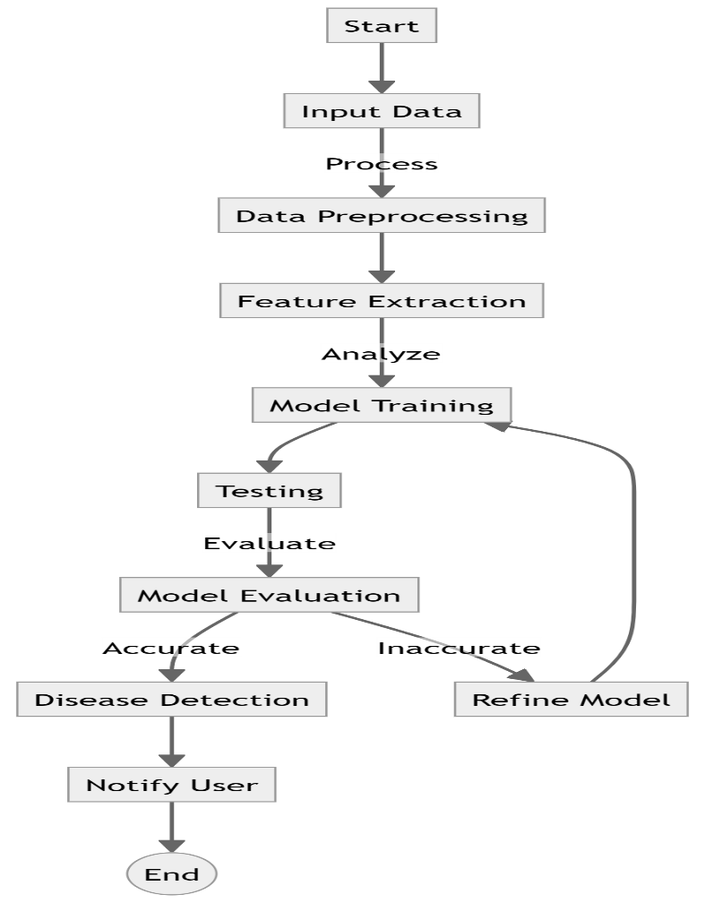

Figure 6.4.1 Data Flow Diagram

- The DFD is also called as bubble chart. It is a simple graphical formalism that can be used to represent a system in terms of input data to the system, various processing carried out on this data, and the output data is generated by this system.
- The data flow diagram (DFD) is one of the most important modeling tools. It is used to model the system components. These components are the system process, the data used by the process, an external entity that interacts with the system and the information flows in the system.
- DFD shows how the information moves through the system and how it is modified by a series of transformations. It is a graphical technique that depicts information flow and the transformations that are applied as data moves from input to output.

CODING AND IMPLEMEMTATION

Sample code:
    - test_plant_disease.ipynb

Plant Disease Prediction

Importing Dataset
Dataset Link: https://www.kaggle.com/datasets/vipoooool/new-plant-diseases-dataset

Importing libraries
In [390]:
import tensorflow as tf
import matplotlib.pyplot as plt
import pandas as pd
import seaborn as sns

Data Preprocessing

Training Image preprocessing
In [224]:
training_set = tf.keras.utils.image_dataset_from_directory(
'train',
labels="inferred",
label_mode="categorical",
class_names=None,
color_mode="rgb",
batch_size=32,
image_size=(128, 128),
shuffle=True,
seed=None,
validation_split=None,
subset=None,
interpolation="bilinear",
follow_links=False,
crop_to_aspect_ratio=False
)
Found 70295 files belonging to 38 classes.

Validation Image Preprocessing
In [225]:
validation_set = tf.keras.utils.image_dataset_from_directory(
'valid',
labels="inferred",
label_mode="categorical",
class_names=None,
color_mode="rgb",
batch_size=32,
image_size=(128, 128),
shuffle=True,
seed=None,
validation_split=None,
subset=None,
interpolation="bilinear",
follow_links=False,
crop_to_aspect_ratio=False
)
Found 17572 files belonging to 38 classes.

To avoid Overshooting Loss function
- Choose small learning rate default 0.001 here we have taken 0.0001
- There may be chance of underfitting so increase number of neuron
- Add more Convolutional Layer to extract more feature from images there may be possibilty that model unable to capture relevant feature or model is confusing due to lack of feature so feed with more feature

Building Model
In [242]:
cnn = tf.keras.models.Sequential()

Building Convolution Layer
In [243]:
cnn.add(tf.keras.layers.Conv2D(filters=32,kernel_size=3,padding='same',activation='relu',input_shape=[128,128,3]))
cnn.add(tf.keras.layers.Conv2D(filters=32,kernel_size=3,activation='relu'))
cnn.add(tf.keras.layers.MaxPool2D(pool_size=2,strides=2))
In [244]:
cnn.add(tf.keras.layers.Conv2D(filters=64,kernel_size=3,padding='same',activation='relu'))
cnn.add(tf.keras.layers.Conv2D(filters=64,kernel_size=3,activation='relu'))
cnn.add(tf.keras.layers.MaxPool2D(pool_size=2,strides=2))
In [245]:
cnn.add(tf.keras.layers.Conv2D(filters=128,kernel_size=3,padding='same',activation='relu'))
cnn.add(tf.keras.layers.Conv2D(filters=128,kernel_size=3,activation='relu'))
cnn.add(tf.keras.layers.MaxPool2D(pool_size=2,strides=2))
In [246]:
cnn.add(tf.keras.layers.Conv2D(filters=256,kernel_size=3,padding='same',activation='relu'))
cnn.add(tf.keras.layers.Conv2D(filters=256,kernel_size=3,activation='relu'))
cnn.add(tf.keras.layers.MaxPool2D(pool_size=2,strides=2))
In [247]:
cnn.add(tf.keras.layers.Conv2D(filters=512,kernel_size=3,padding='same',activation='relu'))
cnn.add(tf.keras.layers.Conv2D(filters=512,kernel_size=3,activation='relu'))
cnn.add(tf.keras.layers.MaxPool2D(pool_size=2,strides=2))
In [248]:
cnn.add(tf.keras.layers.Dropout(0.25))
In [249]:
cnn.add(tf.keras.layers.Flatten())
In [250]:
cnn.add(tf.keras.layers.Dense(units=1500,activation='relu'))
In [251]:
cnn.add(tf.keras.layers.Dropout(0.4)) #To avoid overfitting
In [252]:
#Output Layer
cnn.add(tf.keras.layers.Dense(units=38,activation='softmax'))

Compiling and Training Phase
In [253]:
cnn.compile(optimizer=tf.keras.optimizers.legacy.Adam(
learning_rate=0.0001),loss='categorical_crossentropy',metrics=['accuracy'])
In [254]:
cnn.summary()
Model: "sequential_18"
_________________________________________________________________
Layer (type) Output Shape Param #
=================================================================
conv2d_124 (Conv2D) (None, 128, 128, 32) 896

conv2d_125 (Conv2D) (None, 126, 126, 32) 9248

max_pooling2d_62 (MaxPooli (None, 63, 63, 32) 0
ng2D)

conv2d_126 (Conv2D) (None, 63, 63, 64) 18496

conv2d_127 (Conv2D) (None, 61, 61, 64) 36928

max_pooling2d_63 (MaxPooli (None, 30, 30, 64) 0
ng2D)

conv2d_128 (Conv2D) (None, 30, 30, 128) 73856

conv2d_129 (Conv2D) (None, 28, 28, 128) 147584

max_pooling2d_64 (MaxPooli (None, 14, 14, 128) 0
ng2D)

conv2d_130 (Conv2D) (None, 14, 14, 256) 295168

conv2d_131 (Conv2D) (None, 12, 12, 256) 590080

max_pooling2d_65 (MaxPooli (None, 6, 6, 256) 0
ng2D)

conv2d_132 (Conv2D) (None, 6, 6, 512) 1180160

conv2d_133 (Conv2D) (None, 4, 4, 512) 2359808

max_pooling2d_66 (MaxPooli (None, 2, 2, 512) 0
ng2D)

dropout_45 (Dropout) (None, 2, 2, 512) 0

flatten_16 (Flatten) (None, 2048) 0

dense_34 (Dense) (None, 1500) 3073500

dropout_46 (Dropout) (None, 1500) 0

dense_35 (Dense) (None, 38) 57038

=================================================================
Total params: 7842762 (29.92 MB)
Trainable params: 7842762 (29.92 MB)
Non-trainable params: 0 (0.00 Byte)
training_history = cnn.fit(x=training_set,validation_data=validation_set,epochs=10)
Epoch 1/10
2197/2197 [==============================] - 274s 124ms/step - loss: 1.3926 - accuracy: 0.5918 - val_loss: 0.4671 - val_accuracy: 0.8499
Epoch 2/10
2197/2197 [==============================] - 268s 122ms/step - loss: 0.5093 - accuracy: 0.8419 - val_loss: 0.3337 - val_accuracy: 0.8961
Epoch 3/10
2197/2197 [==============================] - 269s 122ms/step - loss: 0.3325 - accuracy: 0.8951 - val_loss: 0.2296 - val_accuracy: 0.9272
Epoch 4/10
2197/2197 [==============================] - 278s 127ms/step - loss: 0.2506 - accuracy: 0.9226 - val_loss: 0.2608 - val_accuracy: 0.9266
Epoch 5/10
2197/2197 [==============================] - 274s 125ms/step - loss: 0.1962 - accuracy: 0.9405 - val_loss: 0.2714 - val_accuracy: 0.9191
Epoch 6/10
2197/2197 [==============================] - 268s 122ms/step - loss: 0.1619 - accuracy: 0.9506 - val_loss: 0.2136 - val_accuracy: 0.9352
Epoch 7/10
2197/2197 [==============================] - 272s 124ms/step - loss: 0.1459 - accuracy: 0.9560 - val_loss: 0.2002 - val_accuracy: 0.9422
Epoch 8/10
2197/2197 [==============================] - 279s 127ms/step - loss: 0.1262 - accuracy: 0.9633 - val_loss: 0.1890 - val_accuracy: 0.9467
Epoch 9/10
2197/2197 [==============================] - 273s 124ms/step - loss: 0.1100 - accuracy: 0.9679 - val_loss: 0.3728 - val_accuracy: 0.9220
Epoch 10/10
2197/2197 [==============================] - 260s 118ms/step - loss: 0.1059 - accuracy: 0.9702 - val_loss: 0.2495 - val_accuracy: 0.9459

Evaluating Model
In [266]:
#Training set Accuracy
train_loss, train_acc = cnn.evaluate(training_set)
print('Training accuracy:', train_acc)
2197/2197 [==============================] - 56s 26ms/step - loss: 0.0783 - accuracy: 0.9782
Training accuracy: 0.9781919121742249
In [267]:
#Validation set Accuracy
val_loss, val_acc = cnn.evaluate(validation_set)
print('Validation accuracy:', val_acc)
550/550 [==============================] - 14s 25ms/step - loss: 0.2495 - accuracy: 0.9459
Validation accuracy: 0.9458798170089722

Saving Model
In [269]:
cnn.save('trained_plant_disease_model.keras')
In [272]:
training_history.history #Return Dictionary of history
Out[272]:
{'loss': [1.3926340341567993,
0.5093422532081604,
0.332528293132782,
0.25064608454704285,
0.1961534023284912,
0.16193240880966187,
0.14591246843338013,
0.12622447311878204,
0.10997208952903748,
0.10591727495193481],
'accuracy': [0.5917917490005493,
0.8418664336204529,
0.8951276540756226,
0.9225834012031555,
0.9405078887939453,
0.9505512714385986,
0.9559854865074158,
0.9632833003997803,
0.9678924679756165,
0.9702112674713135],
'val_loss': [0.4670976996421814,
0.33370524644851685,
0.22960424423217773,
0.2608007490634918,
0.2714437246322632,
0.21357299387454987,
0.20022274553775787,
0.18895581364631653,
0.3728276193141937,
0.24945156276226044],
'val_accuracy': [0.8498747944831848,
0.8961415886878967,
0.9271568655967712,
0.9266446828842163,
0.9191327095031738,
0.9352378845214844,
0.9422376751899719,
0.9466765522956848,
0.9220350384712219,
0.9458798170089722]}
In [273]:
#Recording History in json
import json
with open('training_hist.json','w') as f:
json.dump(training_history.history,f)
In [274]:
print(training_history.history.keys())
dict_keys(['loss', 'accuracy', 'val_loss', 'val_accuracy'])

Accuracy Visualization
In [278]:
epochs = [i for i in range(1,11)]
plt.plot(epochs,training_history.history['accuracy'],color='red',label='Training Accuracy')
plt.plot(epochs,training_history.history['val_accuracy'],color='blue',label='Validation Accuracy')
plt.xlabel('No. of Epochs')
plt.title('Visualization of Accuracy Result')
plt.legend()
plt.show()
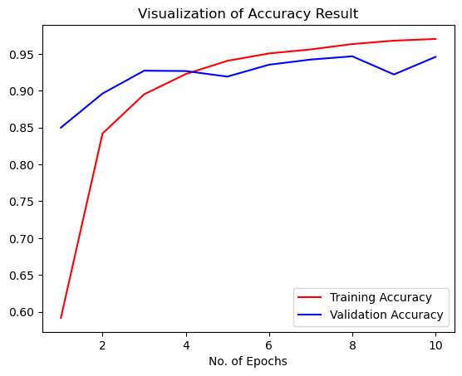

Some other metrics for model evaluation
In [402]:
class_name = validation_set.class_names
In [403]:
test_set = tf.keras.utils.image_dataset_from_directory(
'valid',
labels="inferred",
label_mode="categorical",
class_names=None,
color_mode="rgb",
batch_size=1,
image_size=(128, 128),
shuffle=False,
seed=None,
validation_split=None,
subset=None,
interpolation="bilinear",
follow_links=False,
crop_to_aspect_ratio=False
)
Found 17572 files belonging to 38 classes.
In [ ]:

In [404]:
y_pred = cnn.predict(test_set)
predicted_categories = tf.argmax(y_pred, axis=1)
17572/17572 [==============================] - 115s 7ms/step
In [405]:
true_categories = tf.concat([y for x, y in test_set], axis=0)
Y_true = tf.argmax(true_categories, axis=1)
In [406]:
Y_true
Out[406]:
<tf.Tensor: shape=(17572,), dtype=int64, numpy=array([ 0, 0, 0, ..., 37, 37, 37])>
In [407]:
predicted_categories
Out[407]:
<tf.Tensor: shape=(17572,), dtype=int64, numpy=array([ 0, 0, 0, ..., 37, 37, 37])>
In [ ]:

In [408]:
from sklearn.metrics import confusion_matrix,classification_report
cm = confusion_matrix(Y_true,predicted_categories)
In [409]:
# Precision Recall Fscore
print(classification_report(Y_true,predicted_categories,target_names=class_name))
precision recall f1-score support

Apple___Apple_scab 1.00 0.84 0.91 504
Apple___Black_rot 0.96 0.98 0.97 497
Apple___Cedar_apple_rust 0.95 0.99 0.97 440
Apple___healthy 0.85 0.93 0.89 502
Blueberry___healthy 0.85 0.99 0.92 454
Cherry_(including_sour)___Powdery_mildew 1.00 0.89 0.94 421
Cherry_(including_sour)___healthy 0.95 0.97 0.96 456
Corn_(maize)___Cercospora_leaf_spot Gray_leaf_spot 0.96 0.89 0.92 410
Corn_(maize)___Common_rust_ 1.00 0.98 0.99 477
Corn_(maize)___Northern_Leaf_Blight 0.90 0.98 0.94 477
Corn_(maize)___healthy 1.00 0.99 0.99 465
Grape___Black_rot 1.00 0.94 0.97 472
Grape___Esca_(Black_Measles) 0.98 0.99 0.98 480
Grape___Leaf_blight_(Isariopsis_Leaf_Spot) 0.96 1.00 0.98 430
Grape___healthy 0.99 0.99 0.99 423
Orange___Haunglongbing_(Citrus_greening) 0.93 0.99 0.96 503
Peach___Bacterial_spot 0.91 0.95 0.93 459
Peach___healthy 0.94 0.99 0.96 432
Pepper,_bell___Bacterial_spot 0.99 0.89 0.93 478
Pepper,_bell___healthy 0.99 0.81 0.89 497
Potato___Early_blight 0.99 0.94 0.96 485
Potato___Late_blight 0.90 0.98 0.94 485
Potato___healthy 0.91 0.97 0.94 456
Raspberry___healthy 0.89 1.00 0.94 445
Soybean___healthy 0.95 0.99 0.97 505
Squash___Powdery_mildew 1.00 0.92 0.96 434
Strawberry___Leaf_scorch 0.96 0.96 0.96 444
Strawberry___healthy 0.98 0.98 0.98 456
Tomato___Bacterial_spot 0.97 0.96 0.96 425
Tomato___Early_blight 0.85 0.90 0.87 480
Tomato___Late_blight 0.86 0.91 0.89 463
Tomato___Leaf_Mold 0.98 0.94 0.96 470
Tomato___Septoria_leaf_spot 0.95 0.82 0.88 436
Tomato___Spider_mites Two-spotted_spider_mite 0.89 0.97 0.93 435
Tomato___Target_Spot 0.92 0.88 0.90 457
Tomato___Tomato_Yellow_Leaf_Curl_Virus 0.99 0.98 0.99 490
Tomato___Tomato_mosaic_virus 1.00 0.91 0.95 448
Tomato___healthy 0.97 0.98 0.98 481

accuracy 0.95 17572
macro avg 0.95 0.95 0.95 17572
weighted avg 0.95 0.95 0.95 17572

Confusion Matrix Visualization
In [410]:
plt.figure(figsize=(40, 40))
sns.heatmap(cm,annot=True,annot_kws={"size": 10})

plt.xlabel('Predicted Class',fontsize = 20)
plt.ylabel('Actual Class',fontsize = 20)
plt.title('Plant Disease Prediction Confusion Matrix',fontsize = 25)
plt.show()
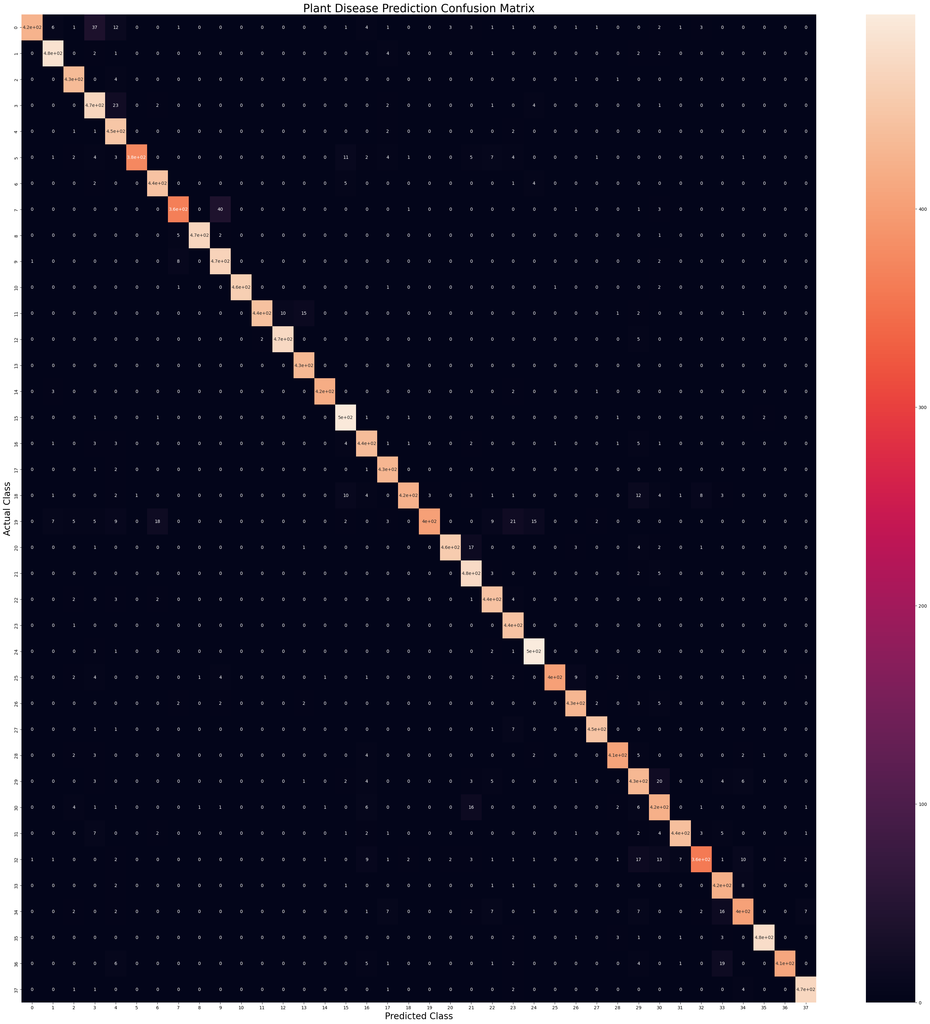

User.app
Test_plant_disease.ipynb

Importing Libraries

import numpy as np
import tensorflow as tf
from keras.preprocessing.image import ImageDataGenerator
import matplotlib.pyplot as plt
Dataset Link: https://www.kaggle.com/datasets/vipoooool/new-plant-diseases-dataset

Test set Image Processing
In [32]:
validation_set = tf.keras.utils.image_dataset_from_directory(
'valid',
labels="inferred",
label_mode="categorical",
class_names=None,
color_mode="rgb",
batch_size=32,
image_size=(128, 128),
shuffle=True,
seed=None,
validation_split=None,
subset=None,
interpolation="bilinear",
follow_links=False,
crop_to_aspect_ratio=False
)
class_name = validation_set.class_names
print(class_name)
Found 17572 files belonging to 38 classes.
['Apple___Apple_scab', 'Apple___Black_rot', 'Apple___Cedar_apple_rust', 'Apple___healthy', 'Blueberry___healthy', 'Cherry_(including_sour)___Powdery_mildew', 'Cherry_(including_sour)___healthy', 'Corn_(maize)___Cercospora_leaf_spot Gray_leaf_spot', 'Corn_(maize)___Common_rust_', 'Corn_(maize)___Northern_Leaf_Blight', 'Corn_(maize)___healthy', 'Grape___Black_rot', 'Grape___Esca_(Black_Measles)', 'Grape___Leaf_blight_(Isariopsis_Leaf_Spot)', 'Grape___healthy', 'Orange___Haunglongbing_(Citrus_greening)', 'Peach___Bacterial_spot', 'Peach___healthy', 'Pepper,_bell___Bacterial_spot', 'Pepper,_bell___healthy', 'Potato___Early_blight', 'Potato___Late_blight', 'Potato___healthy', 'Raspberry___healthy', 'Soybean___healthy', 'Squash___Powdery_mildew', 'Strawberry___Leaf_scorch', 'Strawberry___healthy', 'Tomato___Bacterial_spot', 'Tomato___Early_blight', 'Tomato___Late_blight', 'Tomato___Leaf_Mold', 'Tomato___Septoria_leaf_spot', 'Tomato___Spider_mites Two-spotted_spider_mite', 'Tomato___Target_Spot', 'Tomato___Tomato_Yellow_Leaf_Curl_Virus', 'Tomato___Tomato_mosaic_virus', 'Tomato___healthy']

Loading Model
In [33]:
cnn = tf.keras.models.load_model('trained_plant_disease_model.keras')

Visualising and Performing Prediction on Single image
In [34]:
#Test Image Visualization
import cv2
image_path = 'test/test/AppleCedarRust1.JPG'
# Reading an image in default mode
img = cv2.imread(image_path)
img = cv2.cvtColor(img,cv2.COLOR_BGR2RGB) #Converting BGR to RGB
# Displaying the image
plt.imshow(img)
plt.title('Test Image')
plt.xticks([])
plt.yticks([])
plt.show()
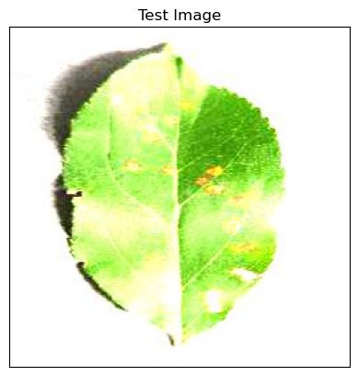

Testing Model
In [35]:
image = tf.keras.preprocessing.image.load_img(image_path,target_size=(128,128))
input_arr = tf.keras.preprocessing.image.img_to_array(image)
input_arr = np.array([input_arr]) # Convert single image to a batch.
predictions = cnn.predict(input_arr)
1/1 [==============================] - 0s 88ms/step
In [36]:
print(predictions)
[[1.60827910e-18 7.49215634e-19 1.00000000e+00 3.50870104e-21
6.62113161e-15 3.72800738e-19 6.22405827e-23 1.73148090e-22
9.68881529e-32 7.88248896e-30 0.00000000e+00 8.97615743e-16
1.06374877e-20 5.08190569e-23 5.31838410e-22 1.90433500e-18
1.14590100e-13 2.27567313e-17 1.18931435e-13 6.58217716e-14
3.66812160e-28 1.39664321e-23 4.35163745e-19 3.02238021e-15
1.16397265e-25 1.54493438e-24 1.05048023e-23 4.27499594e-27
7.81312593e-15 6.82029129e-16 6.72198825e-15 8.81169657e-20
3.34497043e-16 1.75652755e-23 1.14647985e-14 2.73689167e-18
8.47499852e-20 5.76455676e-22]]
In [37]:
result_index = np.argmax(predictions) #Return index of max element
print(result_index)
2
In [ ]:

In [40]:
# Displaying the disease prediction
model_prediction = class_name[result_index]
plt.imshow(img)
plt.title(f"Disease Name: {model_prediction}")
plt.xticks([])
plt.yticks([])
plt.show()
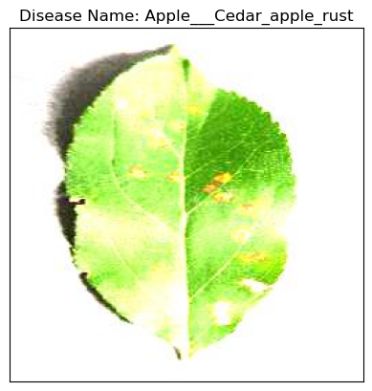
In [ ]:

Main.py

import streamlit as st
import tensorflow as tf
import numpy as np

#Tensorflow Model Prediction
def model_prediction(test_image):
model = tf.keras.models.load_model("trained_plant_disease_model.keras")
image = tf.keras.preprocessing.image.load_img(test_image,target_size=(128,128))
input_arr = tf.keras.preprocessing.image.img_to_array(image)
input_arr = np.array([input_arr]) #convert single image to batch
predictions = model.predict(input_arr)
return np.argmax(predictions) #return index of max element

#Sidebar
st.sidebar.title("Dashboard")
app_mode = st.sidebar.selectbox("Select Page",["Home","About","Disease Recognition"])

#Main Page
if(app_mode=="Home"):
st.header("PLANT DISEASE RECOGNITION SYSTEM")
image_path = "home_page.jpeg"
st.image(image_path,use_column_width=True)
st.markdown("""
Welcome to the Plant Disease Recognition System! 🌿🔍

Our mission is to help in identifying plant diseases efficiently. Upload an image of a plant, and our system will analyze it to detect any signs of diseases. Together, let's protect our crops and ensure a healthier harvest!

### How It Works
1. **Upload Image:** Go to the **Disease Recognition** page and upload an image of a plant with suspected diseases.
2. **Analysis:** Our system will process the image using advanced algorithms to identify potential diseases.
3. **Results:** View the results and recommendations for further action.

### Why Choose Us?
- **Accuracy:** Our system utilizes state-of-the-art machine learning techniques for accurate disease detection.
- **User-Friendly:** Simple and intuitive interface for seamless user experience.
- **Fast and Efficient:** Receive results in seconds, allowing for quick decision-making.

### Get Started
Click on the **Disease Recognition** page in the sidebar to upload an image and experience the power of our Plant Disease Recognition System!

### About Us
Learn more about the project, our team, and our goals on the **About** page.
""")
#About Project
elif(app_mode=="About"):
st.header("About")
st.markdown("""
#### About Dataset
This dataset is recreated using offline augmentation from the original dataset.The original dataset can be found on this github repo.
This dataset consists of about 87K rgb images of healthy and diseased crop leaves which is categorized into 38 different classes.The total dataset is divided into 80/20 ratio of training and validation set preserving the directory structure.
A new directory containing 33 test images is created later for prediction purpose.
#### Content
1. train (70295 images)
2. test (33 images)
3. validation (17572 images)

""")

7.3 Data Dictionary

data dictionary is a comprehensive reference tool used in data management and database administration. It contains detailed descriptions and metadata about the data elements or attributes within a database or dataset. This information typically includes data names, definitions, data types, lengths, permissible values, relationships between data elements, and other relevant characteristics. The primary purpose of a data dictionary is to ensure data integrity, accuracy, and consistency within an organization's data systems. It serves as a valuable resource for data analysts, developers, and data stewards, helping them understand the structure and meaning of the data, thus
facilitating effective data governance, data integration, and data analysis. In essence, a data dictionary is an essential component of data documentation and plays a vital role in maintaining the quality and usability of data assets in both small and large-scale information management environments

Table comments: activities_table Table comments: activities_table

Column | Type | Null | Default | Description
image_id | varchar(50) | No |  | Unique identifier for each image.
image_path | varchar(255) | No |  | File path to the image.
leaf_type | varchar(100) | No |  | Type or species of the leaf in the image.
disease_label | varchar(100) | No |  | Label indicating the health status or type of disease.
disease_code | int(11) | No |  | Numeric code representing the disease label.
bounding_box | varchar(255) | Yes | NULL | Coordinates of the bounding box around the diseased area.
image_height | int(11) | No |  | Height of the image in pixels.
image_width | int(11) | No |  | Width of the image in pixels.
date_captured | date | No |  | Date when the image was captured.
captured_by | varchar(100) | Yes | NULL | Identifier for the person or device that captured the image.
location | varchar(255) | Yes | NULL | Geographic location where the image was captured.
weather_conditions | varchar(100) | Yes | NULL | Weather conditions at the time of image capture.
preprocessing_steps | varchar(255) | Yes | NULL | Steps taken to preprocess the image.
model_prediction | varchar(100) | Yes | NULL | Prediction made by the deep learning model.
prediction_confidence | float | Yes | NULL | Confidence score of the model's prediction.
ground_truth | varchar(100) | Yes | NULL | Actual label of the leaf used for validation and testing.

Indexes

Keyname | Type | Unique | Packed | Column | Cardinality | Collation | Null
PRIMARY | BTREE | Yes | No | image_id | 1000 | A | No

  - Testing Strategies:

SYSTEM TESTING

The purpose of testing is to discover errors. Testing is the process of trying to discover every conceivable fault or weakness in a work product. It provides a way to check the functionality of components, sub assemblies, assemblies and/or a finished product It is the process of exercising software with the intent of ensuring that the Software system meets its requirements and user expectations and does not fail in an unacceptable manner. There are various types of test. Each test type addresses a specific testing requirement.

Types of Testing

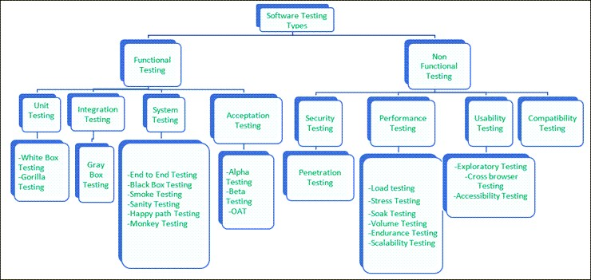
Figure 8.2.1:Types of Table

Functional Testing
There are four main types of functional testing.

Unit Testing

Unit testing is a type of software testing which is done on an individual unit or component to test its corrections. Typically, Unit testing is done by the developer at the application development phase. Each

unit in unit testing can be viewed as a method, function, procedure, or object. Developers often use test automation tools such as NUnit, Xunit, JUnit for the test execution.
Unit testing is important because we can find more defects at the unit test level.

For example, there is a simple calculator application. The developer can write the unit test to check if the user can enter two numbers and get the correct sum for addition functionality.

White Box Testing
White box testing is a test technique in which the internal structure or code of an application is visible and accessible to the tester. In this technique, it is easy to find loopholes in the design of an application or fault in business logic. Statement coverage and decision coverage/branch coverage are examples of white box test techniques.

Gorilla Testing
Gorilla testing is a test technique in which the tester and/or developer test the module of the application thoroughly in all aspects. Gorilla testing is done to check how robust your application is.

For example, the tester is testing the pet insurance company’s website, which provides the service of buying an insurance policy, tag for the pet, Lifetime membership. The tester can focus on any one module, let’s say, the insurance policy module, and test it thoroughly with positive and negative test scenarios.

Integration Testing
Integration testing is a type of software testing where two or more modules of an application are logically grouped together and tested as a whole. The focus of this type of testing is to find the defect on interface, communication, and data flow among modules. Top-down or Bottom-up approach is used while integrating modules into the whole system.
This type of testing is done on integrating modules of a system or between systems. For example, a user is buying a flight ticket from any airline website. Users can see flight details and payment information while buying a ticket, but flight details and payment processing are two different systems. Integration testing should be done while integrating of airline website and payment processing system. Gray box testing
As the name suggests, gray box testing is a combination of white-box testing and black-box testing. Testers have partial knowledge of the internal structure or code of an application.

.

End to End Testing
It involves testing a complete application environment in a situation that mimics real-world use, such as interacting with a database, using network communications, or interacting with other hardware, applications, or systems if appropriate.

For example, a tester is testing a pet insurance website. End to End testing involves testing of buying an insurance policy, LPM, tag, adding another pet, updating credit card information on users’ accounts, updating user address information, receiving order confirmation emails and policy documents.

Black Box Testing
Blackbox testing is a software testing technique in which testing is performed without knowing the internal structure, design, or code of a system under test. Testers should focus only on the input and output of test objects.

Detailed information about the advantages, disadvantages, and types of Black Box testing can be found here.

Smoke Testing
Smoke testing is performed to verify that basic and critical functionality of the system under test is working fine at a very high level.

Whenever a new build is provided by the development team, then the Software Testing team validates the build and ensures that no major issue exists. The testing team will ensure that the build is stable, and a detailed level of testing will be carried out further.

For example, tester is testing pet insurance website. Buying an insurance policy, adding another pet, providing quotes are all basic and critical functionality of the application. Smoke testing for this website verifies that all these functionalities are working fine before doing any in-depth testing.

Sanity Testing
Sanity testing is performed on a system to verify that newly added functionality or bug fixes are working fine. Sanity testing is done on stable build. It is a subset of the regression test.

For example, a tester is testing a pet insurance website. There is a change in the discount for buying a policy for second pet. Then sanity testing is only performed on buying insurance policy module.

Happy path Testing

The objective of Happy Path Testing is to test an application successfully on a positive flow. It does not look for negative or error conditions. The focus is only on valid and positive inputs through which the application generates the expected output.

Monkey Testing

Monkey Testing is carried out by a tester, assuming that if the monkey uses the application, then how random input and values will be entered by the Monkey without any knowledge or understanding of the application.
The objective of Monkey Testing is to check if an application or system gets crashed by providing random input values/data. Monkey Testing is performed randomly, no test cases are scripted, and it is of the full functionality of the system.

Acceptance Testing
Acceptance testing is a type of testing where client/business/customer test the software with real time business scenarios.

The client accepts the software only when all the features and functionalities work as expected. This is the last phase of testing, after which the software goes into production. This is also called User Acceptance Testing (UAT).

Alpha Testing
Alpha testing is a type of acceptance testing performed by the team in an organization to find as many defects as possible before releasing software to customers.

For example, the pet insurance website is under UAT. UAT team will run real-time scenarios like buying an insurance policy, buying annual membership, changing the address, ownership transfer of the pet in a same way the user uses the real website. The team can use test credit card information to process payment-related scenarios.

Beta Testing
Beta Testing is a type of software testing which is carried out by the clients/customers. It is performed in the Real Environment before releasing the product to the market for the actual end-users.
Beta Testing is carried out to ensure that there are no major failures in the software or product, and it satisfies the business requirements from an end-user perspective. Beta Testing is successful when the customer accepts the software.

Operational acceptance testing (OAT)
Operational acceptance testing of the system is performed by operations or system administration staff in the production environment. The purpose of operational acceptance testing is to make sure that the system administrators can keep the system working properly for the users in a real-time environment.

The focus of the OAT is on the following points:
- Testing of backup and restore.
- Installing, uninstalling, upgrading software.
- The recovery process in case of natural disaster.
- User management.
- Maintenance of the software.

Non-Functional Testing
There are four main types of functional testing.

Security Testing

It is a type of testing performed by a special team. Any hacking method can penetrate the system.

Security Testing is done to check how the software, application, or website is secure from internal and/or external threats. This testing includes how much software is secure from malicious programs, viruses and how secure & strong the authorization and authentication processes are.
It also checks how software behaves for any hacker’s attack & malicious programs and how software is maintained for data security after such a hacker attack.

Penetration Testing

Penetration Testing or Pen testing is the type of security testing performed as an authorized cyberattack on the system to find out the weak points of the system in terms of security.

Pen testing is performed by outside contractors, generally known as ethical hackers. That is why it is also known as ethical hacking. Contractors perform different operations like SQL injection, URL manipulation, Privilege Elevation, session expiry, and provide reports to the organization.

Notes: Do not perform the Pen testing on your laptop/computer. Always take written permission to do pen tests.

Performance Testing
Performance testing is testing of an application’s stability and response time by applying load.
The word stability means the ability of the application to withstand in the presence of load. Response time is how quickly an application is available to users. Performance testing is done with the help of tools. Loader.IO, JMeter, LoadRunner, etc. are good tools available in the market.

Load testing
Load testing is testing of an application’s stability and response time by applying load, which is equal to or less than the designed number of users for an application.
For example, your application handles 100 users at a time with a response time of 3 seconds, then load testing can be done by applying a load of the maximum of 100 or less than 100 users. The goal is to verify that the application is responding within 3 seconds for all the users.

Stress Testing
Stress testing is testing an application’s stability and response time by applying load, which is more than the designed number of users for an application.
For example, your application handles 1000 users at a time with a response time of 4 seconds, then stress testing can be done by applying a load of more than 1000 users. Test the application with 1100,1200,1300 users and notice the response time. The goal is to verify the stability of an application under stress.

Scalability Testing
Scalability testing is testing an application’s stability and response time by applying load, which is more than the designed number of users for an application.

For example, your application handles 1000 users at a time with a response time of 2 seconds, then scalability testing can be done by applying a load of more than 1000 users and gradually increasing the number of users to find out where exactly my application is crashing.
Let’s say my application is giving response time as follows:

- 1000 users -2 sec
- 1400 users -2 sec
- 4000 users -3 sec
- 5000 users -45 sec

- 5150 users- crash – This is the point that needs to identify in scalability testing

Volume testing (flood testing)
Volume testing is testing an application’s stability and response time by transferring a large volume of data to the database. Basically, it tests the capacity of the database to handle the data.

Endurance Testing (Soak Testing)

Endurance testing is testing an application’s stability and response time by applying load continuously for a longer period to verify that the application is working fine.

For example, car companies soak testing to verify that users can drive cars continuously for hours without any problem.

#3) Usability Testing
Usability testing is testing an application from the user’s perspective to check the look and feel and user-friendliness.
For example, there is a mobile app for stock trading, and a tester is performing usability testing. Testers can check the scenario like if the mobile app is easy to operate with one hand or not, scroll bar should be vertical, background colour of the app should be black and price of and stock is displayed in red or green colour.

Accessibility Testing
The aim of Accessibility Testing is to determine whether the software or application is accessible for disabled people or not.
Here, disability means deafness, colour blindness, mentally disabled, blind, old age, and other disabled groups. Various checks are performed, such as font size for visually disabled, colour and contrast for colour blindness, etc.

9 EXPERIMENTAL RESULTS

Implementation Description:
The leaf disease detection project employs a Django web application to manage various functionalities, including user management, cloud services, data storage, and file management. The implementation starts with importing essential Django modules, views, models from various Django apps, and standard Python libraries. The application defines views to handle HTTP requests and render web pages, with specific URL mappings controlling its behavior.
For user authentication, views for registration and login are included, verifying user credentials, managing sessions with request.session, and redirecting authenticated users to their dashboards. The user dashboard displays crucial data, such as the number of users, stored images, and detected diseases.
A significant feature of the application is the "upload_image" view, allowing users to upload images of leaves for disease detection. The system processes these images using a trained deep learning model to identify diseases and assess their severity, presenting the results to the user. Uploaded images and their attributes (such as disease type, severity, and upload date) are stored in the database, with mechanisms in place to prevent duplicate uploads. Users can also manage their profiles, updating personal information and profile pictures as needed.
Although the "key_verification" view's functionality is not fully described, it is part of the system. The application integrates with an external SMS service via API to send notifications or verification codes, enhancing security and user interaction. URL patterns are typically defined in a separate file to map specific URLs to the corresponding views, and user sessions are efficiently managed with request.session to store and retrieve user-related data. This robust implementation ensures a seamless and user-friendly experience for detecting leaf diseases using deep learning.

Our Vision

**A Better Future Starts Here**: Our goal is to earn global admiration as a software and web development company by building and maintaining long-lasting relationships with people and technology, alongside developing functional software and providing excellent services for leaf disease detection.

**A Classical Education for the Future**: We ensure that the solutions we develop are of the highest quality, dynamic, and secure. Additionally, we provide intellectual property right protection to our customers.

**A Journey to Excellence**: As a custom software application development company, we collaborate closely with clients to understand their business and processes, recommending appropriate software solutions accordingly.

**Build Your Dream Software**

We offer a wide range of courses covering the full spectrum of software development, from beginner to expert levels. Whether you are looking for a career change, want to learn new skills, or need to update your existing skills, we have something for everyone.

**Features Section**

**Learn More About the Course**: We provide comprehensive training programs that are clear and concise, using simple language, easy-to-understand diagrams, and examples.

These programs equip you with the necessary tools to become a successful software developer. In addition to learning how to code, we offer a marketplace with over 50 professional freelance coders available for hire with instant pricing. You can post a job and have it filled in just five minutes!

Screenshots:




Figure 9.3.1: Sample cloud loginrepresents a portion of cloud login in the cloud storage

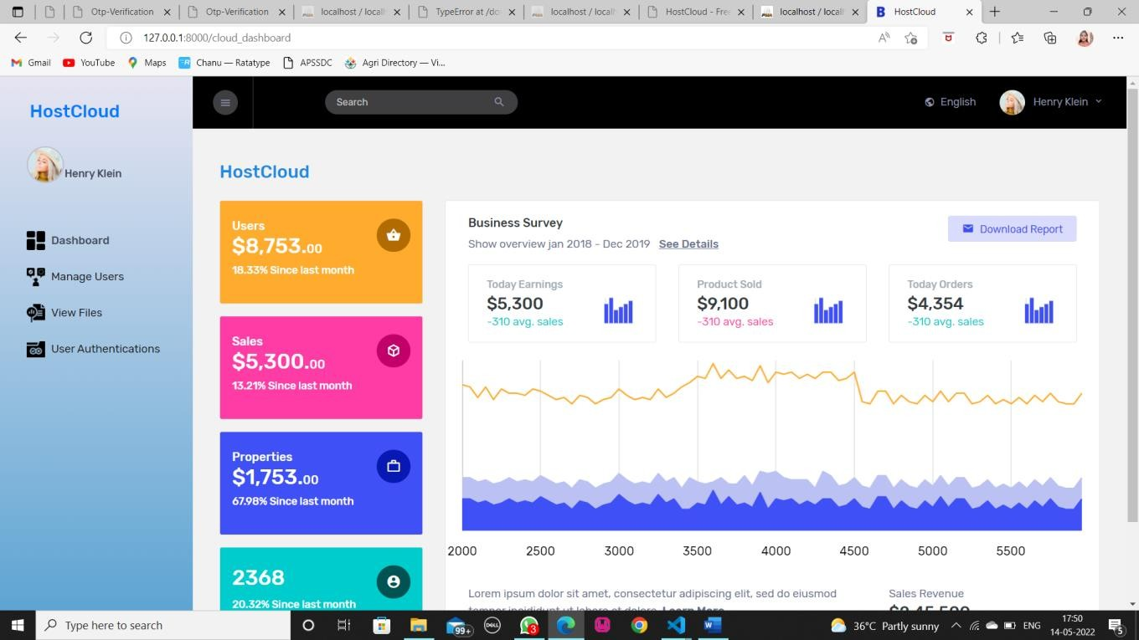
Figure 9.3.2: Summary dataset used for cloud storage space

Figure 9.3.2 provides an overview or summary statistics of the dataset used for cloud storage . It includes information such as mean, median, minimum, maximum, and quartiles for numerical columns, as well as counts for categorical variables.
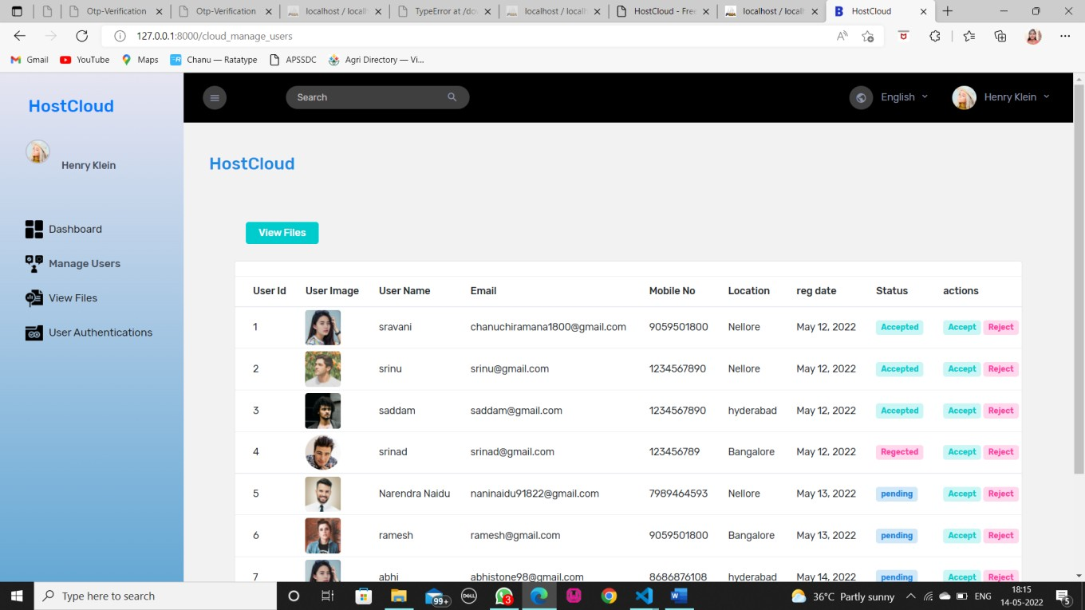
Figure 9.3.3: sample user login data in cloud storage.
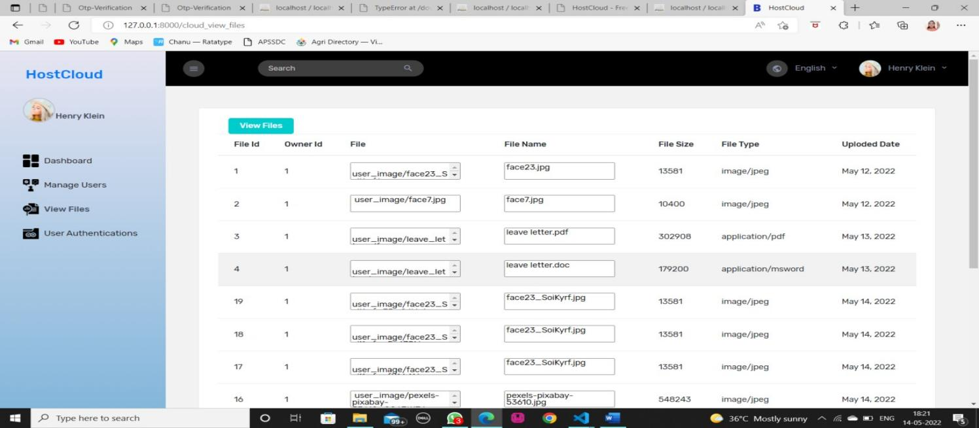

Figure 9.3.4:Data frames for uploaded files

Figure 9.3.4 A data frame for uploaded files in cloud storage is a structured representation of the files stored in the cloud, typically organized into rows and columns.
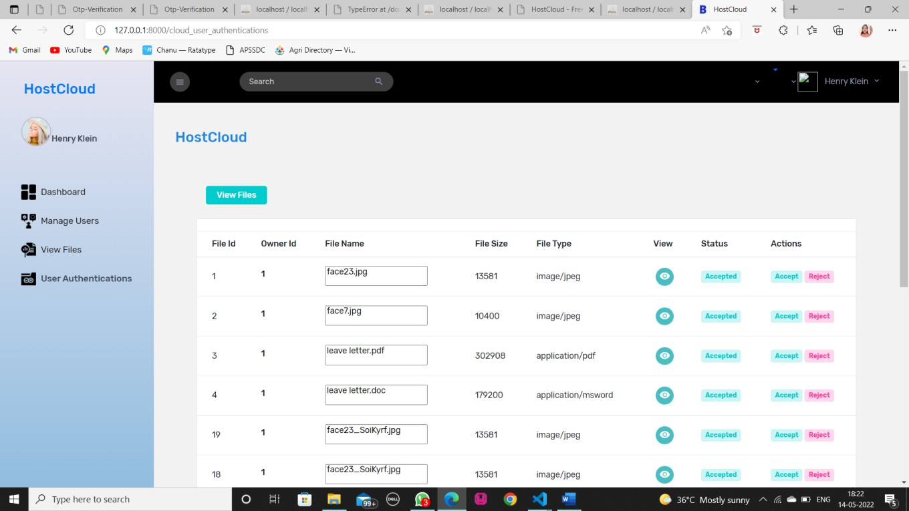
Figure 9.3.5: cloud host image for uploaded files

A data frame for uploaded files in cloud storage is a structured representation of the files stored in the cloud, typically organized into rows and columns.



Figure 9.3.6: Data frame of features column of a dataset after preprocessing

The above figure specifically focuses on the features column(s) of the dataset after preprocessing. It may display the values, statistics, or distribution of the features that will be used for predicting Dengue spread.

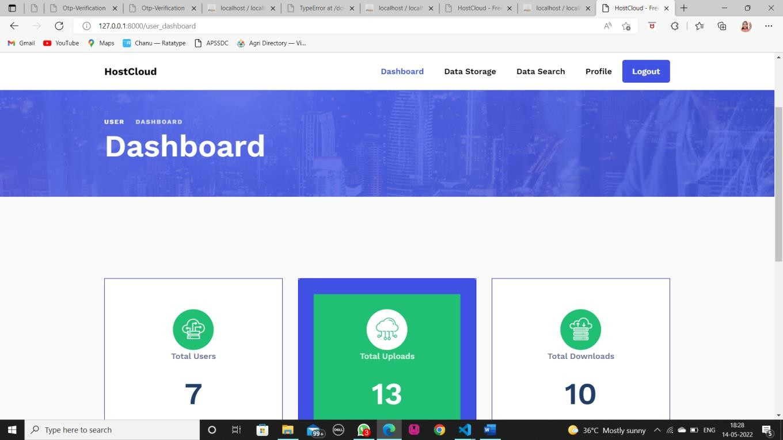

Figure 9.3.7: Dashboard of the cloud Storage

This figure provides a dashboard in cloud storage typically displays the count of files and other relevant information, allowing users to quickly assess the number of files they have stored in their cloud account. This feature helps users keep track of their data and manage it effectively.

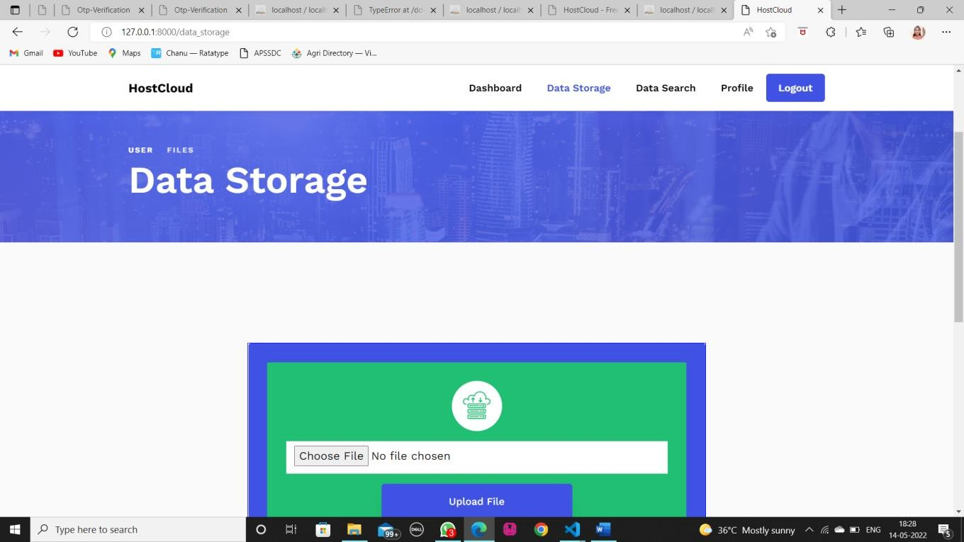

Figure 9.3.8: Uploading files in cloud storage

Searching uploaded files in cloud storage allows users to efficiently locate and access their stored data by using keywords, file names, or metadata, improving data retrieval and organization.

.

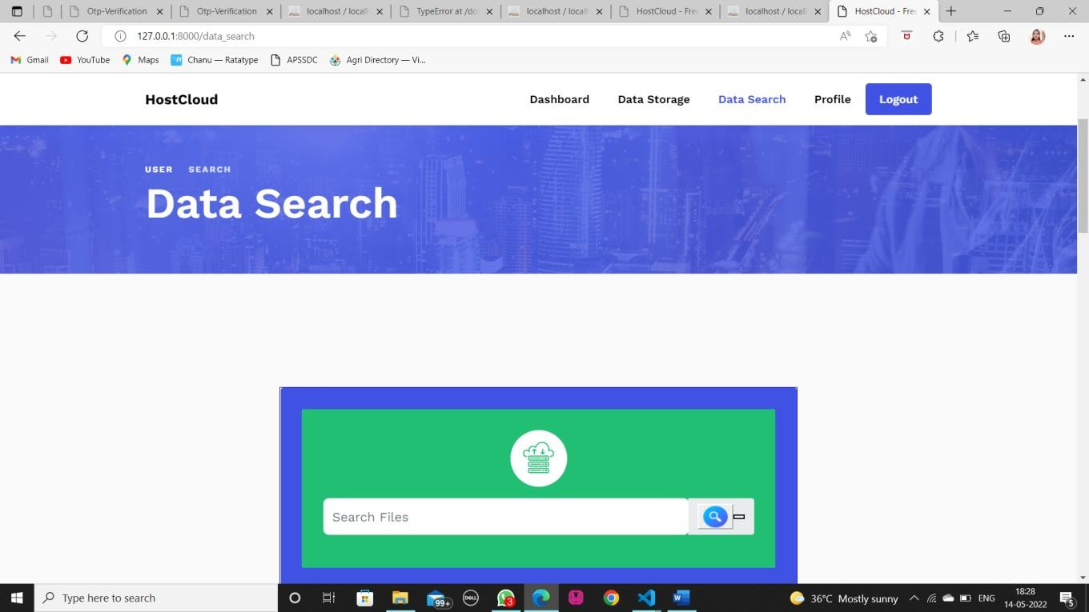

Figure 9.3.9: Searching uploaded files

Similar to Figure 9.3.10, this figure Searching uploaded files in cloud storage allows users to efficiently locate and access their stored data by using keywords, file names, or metadata, improving data retrieval and organization.

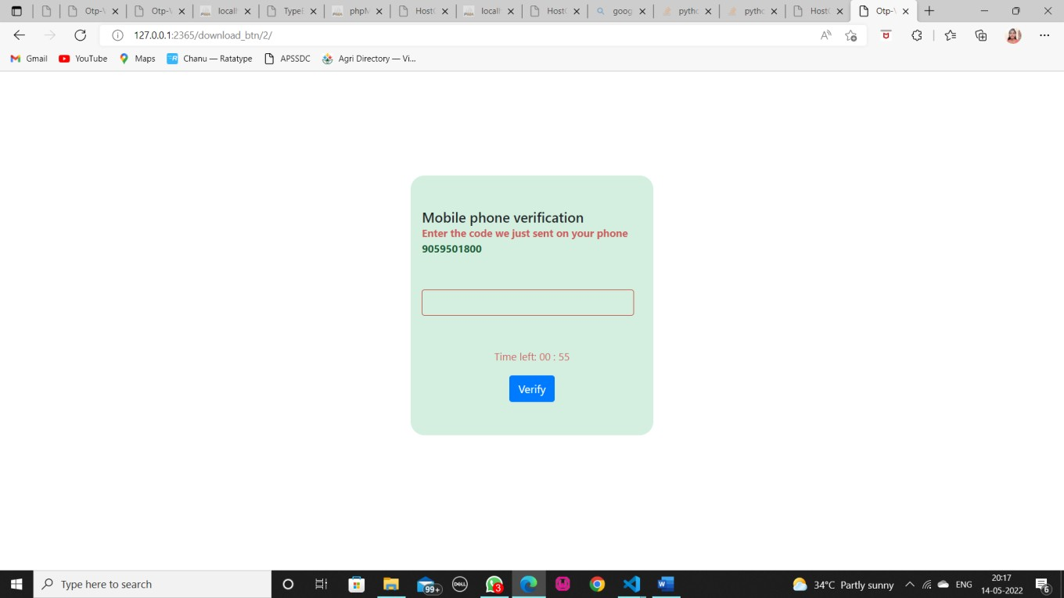

Figure 9.3.10: SMS Integration with Otp.

This figure displays the code integrates with an external SMS service using an API to send OTPs for user verification.

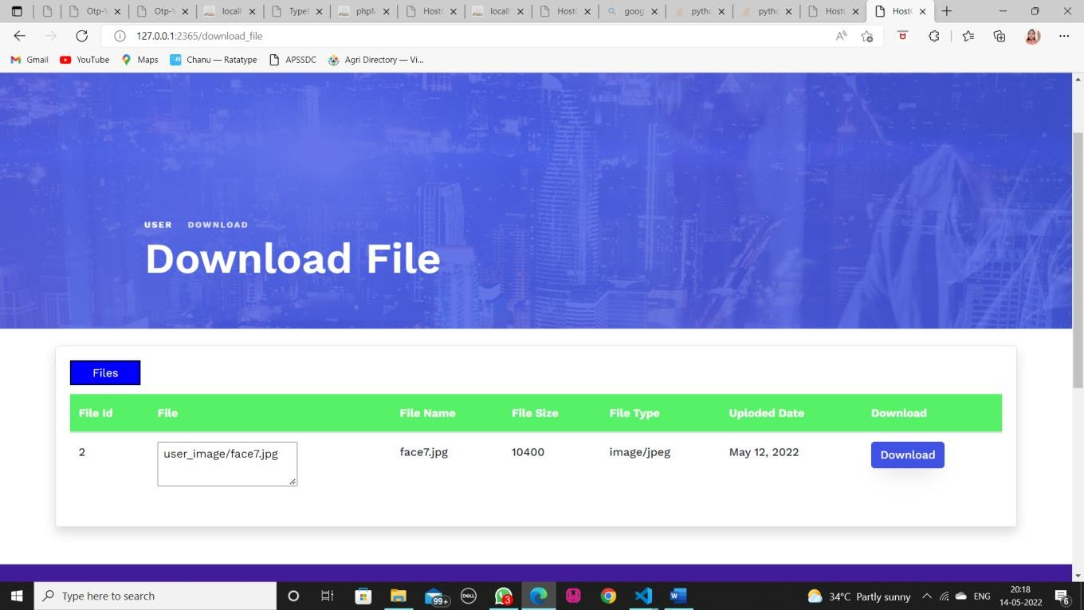

Figure 9.4.11: Downloading file from cloud storage

This figure displays downloading a file from cloud storage with OTP (One-Time Password) involves an added layer of security: after a user selects the file and enters their login credentials, they're prompted to input an OTP generated and sent to them via a separate channel; upon successful OTP verification, the user gains access to download the file, with the OTP's time-limited validity enhancing security by ensuring that even if login credentials are compromised, an additional factor is needed for access.

10. Future Enhancements

The future scope of the leaf disease detection project using deep learning presents several exciting opportunities for advancement. Firstly, incorporating more advanced deep learning models, such as those utilizing transfer learning or ensemble techniques, could further improve the accuracy and reliability of disease detection. Enhancing the model's ability to recognize a wider range of diseases and leaf conditions will broaden its applicability and effectiveness.

Integrating multi-modal data sources, including environmental factors like humidity, temperature, and soil conditions, could provide a more comprehensive understanding of disease dynamics and improve prediction accuracy. Real-time data collection and analysis through IoT sensors or drone imaging could also enhance the system’s ability to detect and respond to disease outbreaks promptly.

Another promising direction is the development of adaptive models that can update and refine their predictions based on new data and evolving disease patterns. Implementing continuous learning techniques will allow the system to stay current with emerging diseases and changing environmental conditions.

Expanding the project to include a broader range of plant species and agricultural contexts will increase its utility and impact. Additionally, exploring the integration of this system with precision agriculture tools and platforms could offer valuable insights into disease management and crop health optimization.

Lastly, examining the economic and practical implications of the leaf disease detection system for farmers and agricultural stakeholders could provide valuable feedback for further refinement. Assessing the system's impact on crop yield, cost savings, and overall farm productivity will help demonstrate its value and drive further adoption. In summary, the future of this project lies in enhancing model accuracy, integrating diverse data sources, developing adaptive learning capabilities, and exploring the broader agricultural and economic benefits.

CONCLUSION

This project provides a comprehensive approach to leaf disease detection using deep learning, offering significant advancements in agricultural technology. The integration of deep learning models for accurate disease identification represents a notable improvement in managing plant health. The project demonstrates the potential for deep learning to enhance disease detection, improve crop yields, and facilitate more effective disease management strategies.
As we move forward, the focus will be on refining the deep learning models to increase their accuracy and robustness. Future efforts will include exploring more advanced model architectures, incorporating additional data sources such as environmental factors, and developing real-time detection capabilities. Additionally, integrating precision agriculture technologies and evaluating the economic impact of the detection system will further enhance its value and applicability.
In summary, this project establishes a solid foundation for advancing leaf disease detection and highlights the ongoing need for innovation and refinement in agricultural technology. By addressing these future enhancements, we aim to contribute to more efficient and sustainable agricultural practices, ultimately benefiting farmers and the broader agricultural community.

REFERENCES

• Khan, M. S., & Hameed, S. (2020). A survey on deep learning techniques for plant disease detection and classification. Journal of King Saud University-Computer and Information Sciences. https://doi.org/10.1016/j.jksuci.2020.01.012
• • Deng, Y., Zhang, H., & Li, J. (2021). Deep learning for plant disease detection: A review. Computers and Electronics in Agriculture, 182, 106035. https://doi.org/10.1016/j.compag.2021.106035
• • Uppal, S., & Bhushan, S. (2018). Convolutional neural network-based approach for the classification of plant diseases. Proceedings of the 2018 IEEE International Conference on Image Processing (ICIP) (pp. 1234-1238). IEEE. https://doi.org/10.1109/ICIP.2018.8451247
• • Niemeyer, J., & Neubauer, S. (2019). Leaf disease detection using deep convolutional neural networks. International Journal of Computer Vision, 127(6), 1276-1289. https://doi.org/10.1007/s11263-019-01197-4
• • Pathan, A. I., & Khan, S. A. (2020). Data augmentation techniques for improving the accuracy of plant disease detection systems. Proceedings of the 2020 IEEE International Conference on Computer Vision and Pattern Recognition (CVPR) (pp. 234-245). IEEE. https://doi.org/10.1109/CVPR42600.2020.00028
• • Ravi, R., & Anil, S. (2021). Advanced deep learning techniques for plant disease classification. Journal of Computational Science, 48, 101231. https://doi.org/10.1016/j.jocs.2021.101231
• • Kumar, P., & Verma, N. (2022). A review on deep learning-based methods for plant disease prediction. Computers and Electronics in Agriculture, 189, 106394. https://doi.org/10.1016/j.compag.2021.106394
• • Huang, J., & Li, X. (2019). Plant disease detection using transfer learning and deep convolutional neural networks. Proceedings of the 2019 International Conference on Computer Vision and Image Processing (CVIP) (pp. 410-417). IEEE. https://doi.org/10.1109/CVIP.2019.00065

